Stakeholder consultation procedure: the co-design process
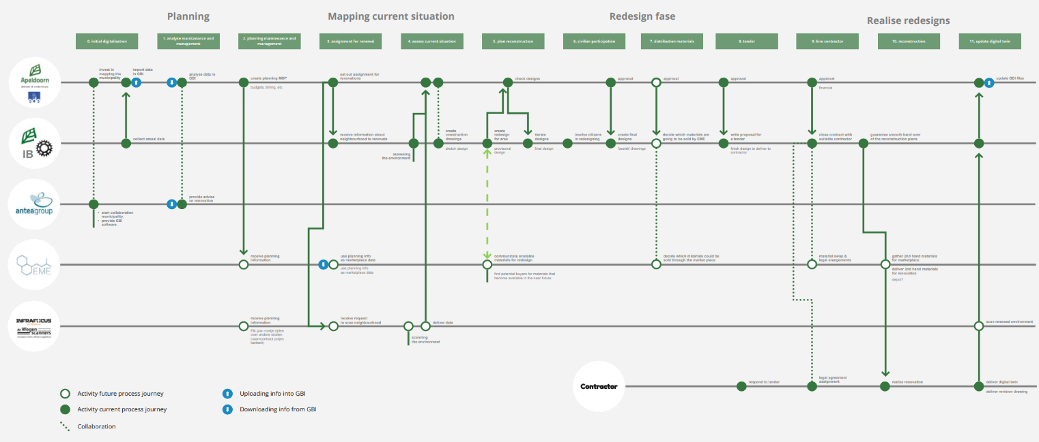
CDW

Description
When preparing a circular construction project, multiple actors and stakeholders are involved. However, difficulties can be experienced in aligning these actors and stakeholders to come to an executable project. During an experiment in the municipality of Apeldoorn, a co-design process, based on the method of service design, was used to develop a process journey. This process journey (concisely shown in the picture at the top of this page) is an overview of the involved actors per process phase. To collaboratively complete deliverables, it shows the roles and tasks each actor is expected to fulfil. As such, the process journey can form a manual instruction to accomplish the desired project circularly. Important to mention is that actors are defined here as stakeholders that can directly influence or take decisions influencing the outcome of the project. This could be persons, departments, or companies, operating on behave of the municipality, as well as external stakeholders, e.g. contractors or subcontractors.

Table 1. Organizations and departments in the process journey (format derived from Entrop, et al., 2022).
Actor | Role(s) of the organization | Role(s) in the project
<Name of the actor using department name, company name, or person name> | <General role of the organization, department, company, or person> | <Specific role of the organization, department, company, or person within the project>
<…text…> | <…text…> | <…text…>
<Please feel free to add more rows to add actors when necessary> | <…text…> | <…text…>
Before starting the co-design process, the actors and stakeholders involved need to be identified. Table 1 can assist in coming to a concise overview and can be regarded as the first element of this tool.

After identifying the actors and stakeholders, five steps in the co-design process can be distinguished that might help to come to a clear process journey. For the situation of the circular road renovation project Griffiersveld in the municipality of Apeldoorn, these five steps can be generally described as follows (Entrop, et al., 2022):
- Interview all involved actors and stakeholders to get an idea of their perception of the current road construction process;
- Map the current process and the collaboration between the actors and stakeholders involved as a process journey;
- Reflect on the process journey as mapped in the previous step and finetune until everyone agrees on their roles and the deliverables;
- Identify chances and opportunities for improving the current process journey into a circular process journey;
- Choose during so-called ‘sprints’ the most rewarding chances and opportunities to realize. The results of these sprints can be laid down in the circular process journey.

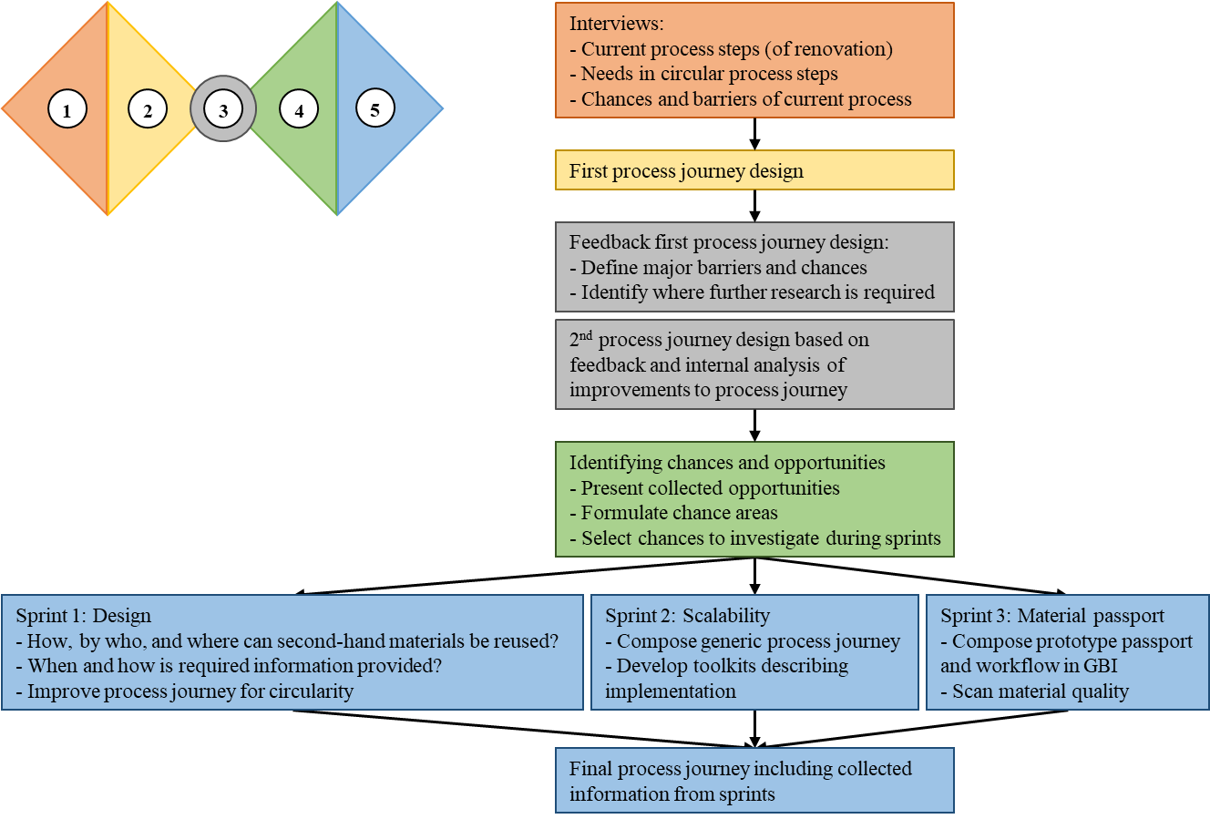
Figure 1. Overview of the complete co-design trajectory resulting in a final process journey based on the double-diamond diagram.

Figure 1 provides insights into how data was collected and the process was organized in the case of the circular road renovation project in Griffiersveld in the Dutch municipality Apeldoorn. In this figure, the steps are visualized based on the double-diamond diagram, a commonly used tool when applying service design. Therefore, the colours of the process as executed in Griffiersveld correspond with the colours of the double-diamond diagram.
Keywords:
- Co-design process
- Actors
- Roadmap
- Road renovation
- Circularity
Target user:
- Initiators or principals in the road construction industry;
- Road inspection services;
- Asphalt or paver manufacturers;
- Contractors and sub-contractors in road demolition and construction projects.
Format:
The tool is developed as a roadmap in which five steps to come to the circular process journey are described. Since the first step includes interviewing actors and stakeholders, a table to develop a clear overview of actors is provided. Furthermore, examples of a process journey and results of the sprints, as executed in the last step of the roadmap, are provided in the form of a manuscript on the situation of the circular road renovation project in Griffiersveld Apeldoorn.

Development
Together with the external process facilitator Koos Service Design the steps to come to a circular process journey were executed. In October 2020, the co-design process started by interviewing actors and stakeholders. Based on these interviews, a first process journey was designed. From November 2020, the chances and opportunities were mapped. In January and February 2021, sprints were executed. The final presentations of this co-design process took place in April 2021.

Barriers:
Although coming to circular material usage in road renovation projects highly motivated contractors to execute the process that are needed, it is not, due to European public tendering rules, an easy task to just invite contractors to participate in the co-design process.
Design thinking forms the basis when going through the service design process. It may take time to develop and apply this way of thinking.
“Service design does not have distinct expertise in the circular economy by itself. Its tools inspire and enable an intrinsic transition to design a new system collaboratively.” (Koos Service Design, 2022, p.43).
“Most of the transformations need to happen in the market, not in the municipality itself.” (Koos Service Design, 2022, p. 44).

Deployment
In the municipality of Apeldoorn, this tool is used to map collaboration across actors in multiple phases of a road renovation project. In the process journey, actors were involved with a profound knowledge of road quality and road materials. Residents were not included. However, the involvement of residents in the circular road renovation process was captured in another way, as will be set out in another manuscript and accompanying tool factsheet. At an international conference in Berlin (Germany) the co-design process as experienced in Apeldoorn will be disseminated in form of a paper and a presentation so that other organizations might be able to come to more circular processes.

Replication
The roadmap is generic and applicable for design-driven projects in other cities worldwide. However, it has not yet been tested beyond the H2020 CityLoops project in the municipality of Apeldoorn. When following the roadmap, the output will be a circular process journey. This output adds to the possibility to compare cities nationally and across countries.
To make use of the tool successfully, the developers recommend having an open mind to opportunities to include organizations with knowledge of and experience in developing material passports and closing materials loops. Please, do not stay away from those who currently are not yet part of the construction processes. Furthermore, it is important to involve stakeholders throughout the co-design process to make them owners of the process and to increase their sense of responsibility. In this way, stakeholders can share their insights within their organization and spread this way of working and thinking.

References
Entrop, A. G., Hagen, L., & Van Leeuwen, J. P. (forthcoming). Aligning actors in a road renovation project by a co-design process: the road to circularity?
Koos Service Design (2022). Service design for a circular economy; 5 steps on how to make your circular vision concrete. Retrieved from https://www.koosservicedesign.com/
Leeuwen, J. van (2021). Paving the Way for Sustainable Change; Co-creating a circular reality through service design. Touchpoint 12(3), pp. 47-49.

Developed by
Koos Service Design developed the process journey in collaboration with the municipality of Apeldoorn, the Netherlands. Saxion University of Applied Sciences took care of the reporting on and evaluation of the co-design process.
Contact: Joost van Leeuwen, joost@koosservicedesign.com, Bram Entrop, a.g.entrop@saxion.nl
