Procurement guide for usage of biogas as a motive power in transportation and logistics services
Developed by: City of Mikkeli, Finland
Ilkka Liljander, ilkka.liljander@mikseimikkeli.fi
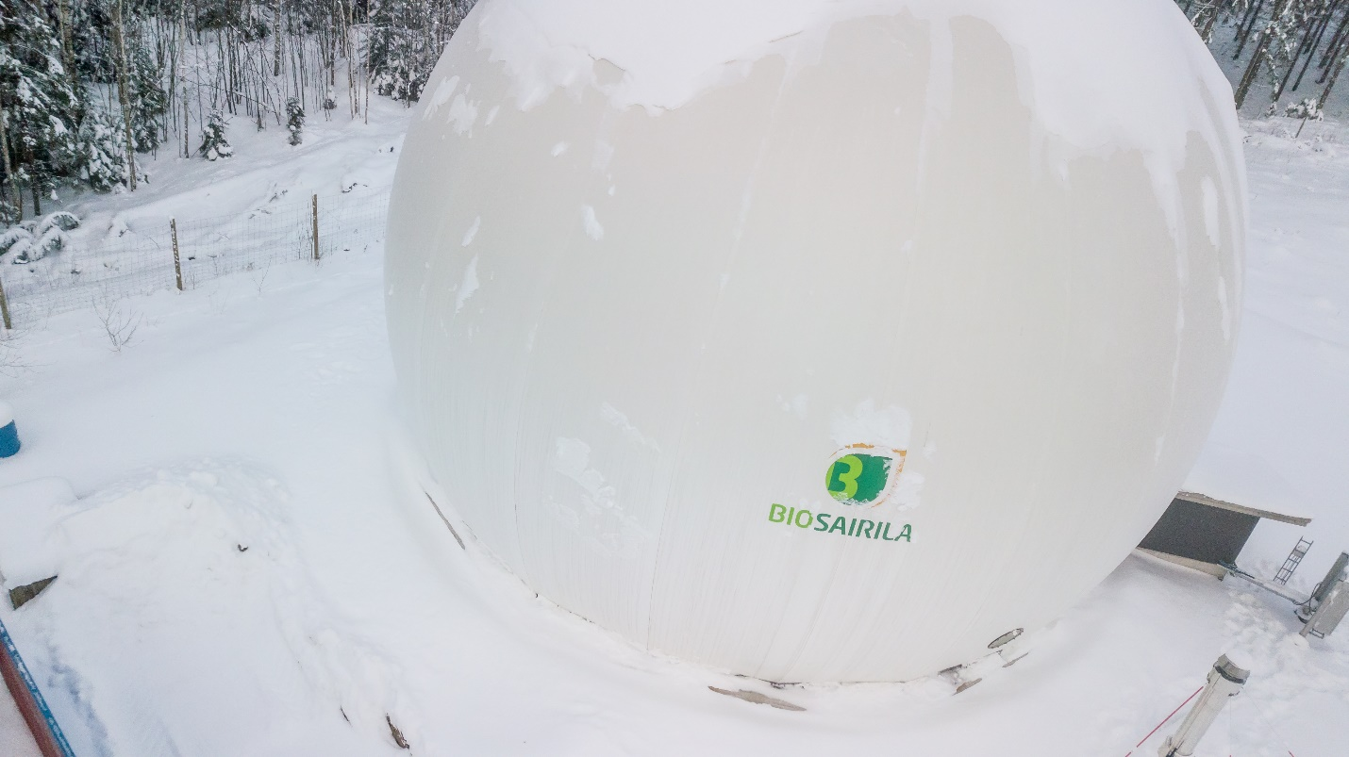

Short Introduction

This tool can be utilised as a guide for reducing unprocessed organic waste creation and promote the utilisation of organic waste in biogas production. It aims to support the procurement of public transportation and logistics services in a way that the reduction of carbon dioxide emissions is eminent and the demand of biogas as a motive power is included in the tenders. It also supports the goal of closed cycle of organic waste and its end products. Further on it supports the work of the city of Mikkeli’s to reach green deal ambitions and goals.

Deployment
This tool will be utilized by the professionals in Mikkeli City concern who are involved in planning and preparing public procurement processes and tenders. Tool is aimed to provide support for public procurement when tender and its scope is focused to transportation or logistics or furthermore includes such support services of any kind. It provides the clues, questions and examples of how to pay attention to biogas as a potential motive power used in vehicles within the service production.

Replication
Replication for other municipalities and cities could be useful especially for the rural area cities and municipalities of the same size and further to the cities or municipalities that promote the production and use of biogas and its creation process end products.

Development
- The tool is under development and it is due to be finalized at the end of March 2021. To process for gathering the information for the tool included stakeholder interviews of transportation experts, procurement experts, private consulting experts related to the local transportation development plan and experts of several other branches in the city of Mikkeli.

