General guide for organic waste management in public procurement
Developed by: City of Mikkeli, Finland
Ilkka Liljander, ilkka.liljander@mikseimikkeli.fi
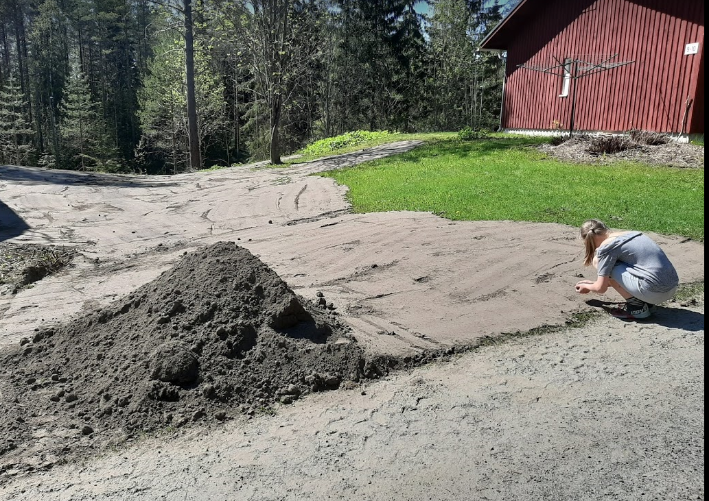

Short Introduction
This tool can be utilised as a general guide for managing organic waste creation and handling in public procurement and public procurement related processes and functions. This tool aims to enhance the collection and sorting of organic waste and reducing carbon dioxide emissions in services and functions based on public procurement in the City of Mikkeli. It also aims to enhance the utilisation of organic waste. Further on it supports the work of the city of Mikkeli’s to reach green deal ambitions and goals. Tool helps the experts within Mikkeli city’s organisation to identify the links to the reduction, handling or reuse of organic waste in a single tender within the wide scope of procurement processes. It will enhance the neutrality and quality of the tenders within different branches.

Deployment
This tool will be utilized by the professionals in Mikkeli City concern who are involved in planning and preparing public procurement processes and tenders. Tool is aimed to provide support for public procurement in all branches. It provides the clues, questions and examples, of how to pay attention to organic waste and it’s creation when organising city’s activities and services through public procurement.

Replication
Replication for other municipalities and cities could be useful especially for the rural area cities and municipalities of the same size and further to the cities or municipalities that promote the reduction and reuse of organic waste and its handling process end products.

Development
The tool is under development and it is due to be finalized at the end of March 2021. To process for gathering the information for the tool included stakeholder interviews of transportation experts, procurement experts, private consulting experts related to the local transportation development plan and experts of food and cleaning services in the city of Mikkeli.

