Lifecycle CO₂e Calculator for Demolition and Renovation Sites
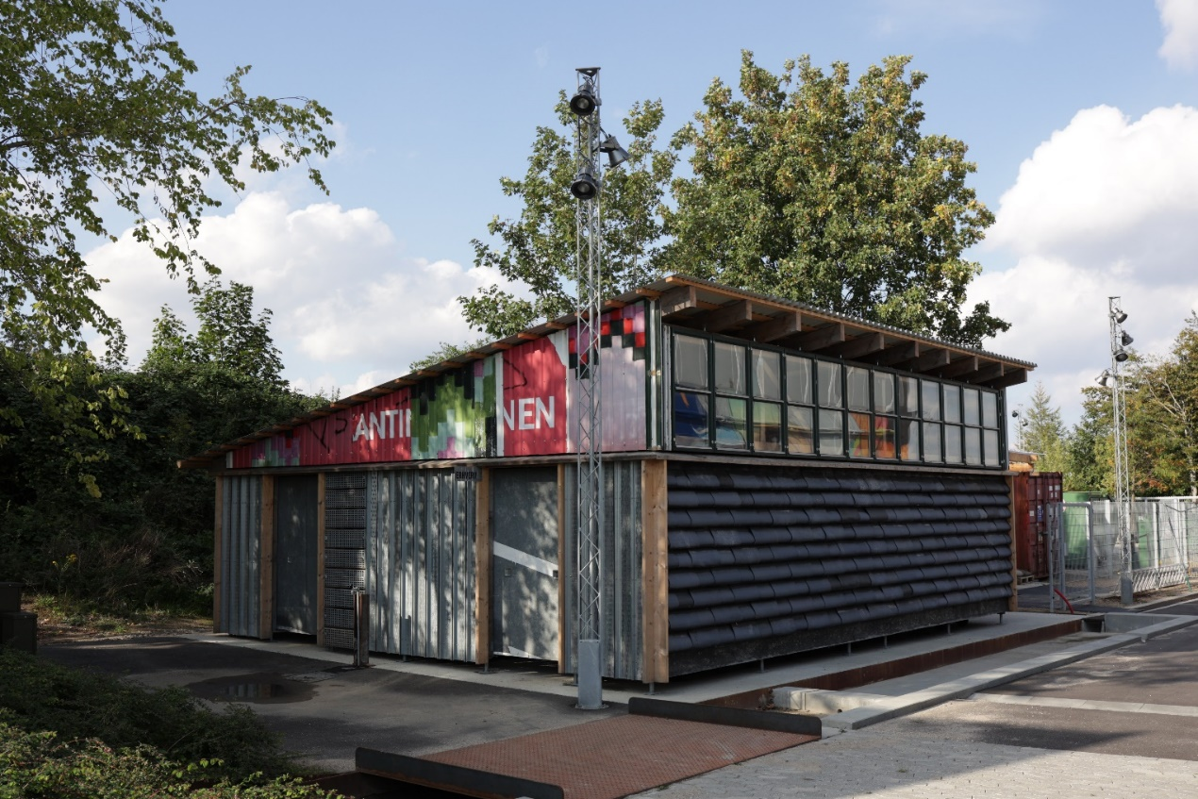
CDW

Description:
Circular economy approaches focus on maintaining the value of materials for as long as possible. A circular economy seeks to keep materials in circulation, minimising the concept of waste from the system and the need for virgin material extraction from primary sources. In a completely circular economy, waste production should align completely with the input of new products. If the built environment is thought about in this way, as a system, then the inputs are construction materials, and these materials accumulate in buildings, which can also be thought of as the stock. Demolition waste is the output flow of materials in this system.

Embodied carbon can be contemplated the same way. When new products are introduced to a building, the materials come with a carbon “price”, which is the amount of carbon associated with the production, transport and handling of the building materials. This means, if we extend the idea, that a material bank not only will help minimise the need of new materials from primary sources (virgin materials), but it is also a way of maintaining embodied carbon in the materials and thereby avoiding emissions outside the system.

The effect of maintaining embodied carbon in a closed material loop is seen throughout the different life cycle stages. The life cycle stages are divided into several main groups according to EN 15804 and 15978, which are the European standards for Life Cycle Assessments (LCA) in the built environment.

The principles of LCA and circular economy are based on the same basic principles of circularity and therefore allow us to overlay the LCA methodology on circular economy in general.

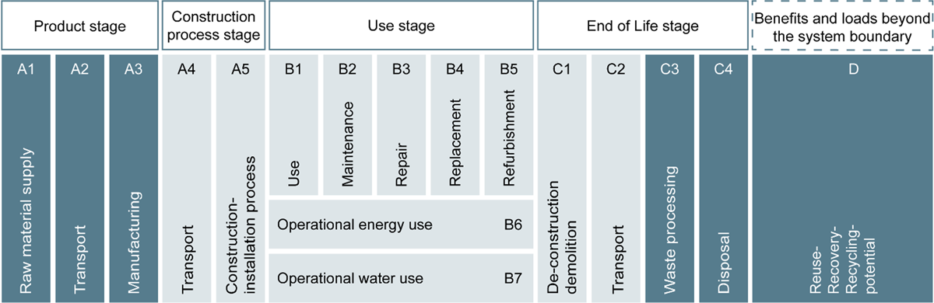

This means that the carbon saving potential in circular economy is not isolated to the production process itself. There is also a carbon saving potential in the construction stages and in the end of life stages. Take, for example, wood as construction material. When timber grows in the forest it accumulates carbon and embeds it in the biomass. The accumulated carbon remains in the wood until it is released again at the end of life stage, therefore extending the lifespan of the product will prevent the carbon from being released to the atmosphere.

“The system boundary is defined by the cut-off allocation method according to EN 15804/15978, where the first and second lives of the element are considered as two independent life-cycles. In the first life-cycle, the building element/component is considered until the material reaches the end-of-waste state. In the second life-cycle in the product stage (A1–A3), only the processing of the element/component to be transformed into a new product is included, hence the recycled and reused materials themselves are considered as ‘free’ and without impact.”
Andersen, C. E., et al. (2020)

The adoption of circular economic design approaches that facilitate longer building lifetimes, greater component and material reuse can reduce the input flow of embodied emissions and ensure already expended embodied carbon remains in stock.

Not only is it important to keep materials and embodied carbon in the circular loop, it is also important to minimise the need for adding new energy to the processes within the loop. In other words, circular processes should be as tight as possible, preventing added energy through unnecessary material (re-) manufacturing. The principle of keeping the loop tight is best illustrated through differentiating the circular processes into four individual loops within the circular framework.
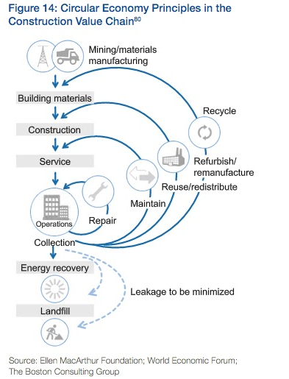
Repair describes the principle of keeping a material in its original form and function in the same location in a building, only adding minimum energy and no material, e.g. tightening a bolted connection.

Remain/ Maintain describes the same as repair, but it can be necessary to add new materials in order to keep the original form and function in the building, e.g. painting a wall.

Reuse describes the principle where a material keeps its original form and function, but not necessarily in the same location. This introduces additional energy consumption for transport and handling. However, the process can be carried out locally, e.g. cutting concrete wall into smaller slabs for another use.
Recycle describes the process of letting a construction material re-materialise in a new form and function. This almost always means adding both energy and materials to the process, e.g. crushing old concrete and mixing it with cement for new moulds.

Even though it seems obvious, aiming at as tight a loop as possible also comes at a price. The tighter the loop is, the smaller the freedom or flexibility of use. When repairing, you even can't change the colour - while when recycling, there are almost no limits to the form, function and location of the material. This is the balance that all building owners should be aware of and should have the tools to evaluate.

In the CityLoops project, the focus is on creating operational tools that will help buildings owners, architects, engineers, contractors etc. in their decision making. This is especially true for the Lifecycle CO₂e Calculator tool.

This tool and the underlying LCA method can be used to calculate the lifecycle CO₂e impact of concrete, soil, or mixed CDW. It can be used in planning processes for building demolition and renovation projects to aid in decision making and in procurements, with lower emissions as an award criterion. This tool supports the reduction of CDW and soil waste, as well as the associated carbon emissions, by allowing comparison of possible actions for informed decision-making. The mixed CDW tool takes a holistic perspective on CDW and is calculated in 3 parts – the embodied carbon reference value for the material itself, the potential carbon saving for recycling, and the potential carbon saving for direct reuse - and soil, which is calculated separately. It includes 11 material categories – representing the main construction materials based on EU norms: concrete, sand and gravel, soil, bricks, glass, gypsum, construction steel, bitumen/ asphalt, aluminium, insulation and timber. The method is simple and practical; it should be used as a decision making tool, to get quick feedback on the carbon impact of different options.
Keywords:
- #Demolition; #Renovation
- #Procurement
- #Decision making; #Planning
- #Reduce
Complementary tools:
- Pre-demolition screening procedure, Selective demolition procedure, CDW quality assessment, Material passport and databank, Material marketplace
Target user:
- Local governments - (e.g. departments of buildings & infrastructure, environment, urban development, procurement)
Format:
- 3 Excel sheets, including instructions – 1 each for concrete, soil, and mixed CDW (available in English and Danish)
*Expected to become a web-based calculation tool

Development
The tools have been developed through a longer period of experimentation and research, in which the focus has been on combining specific data for a specific project with generic background data (on embodied emissions of each material type, considering carbon impacts of different handling options).
- Data from Okobaudat, Bauen und Umwelt, Build and local data has been used.
- Niras Engineering and XP journey

Barriers:
There were difficulties in retrieving sufficient background data, and ensuring the data used is representative of as much of the EU as possible.

Deployment
The soil tool is already in use in the municipality of Roskilde. It is used as a simple way to quantify CO₂e saving potential in different tenders. The tool is sent out with tenders and allows the bidders to deliver a figure for the CO₂e saving potential associated with their proposed project.

The mixed CDW tool is a decision making tool, and will be used within Roskilde municipality in the early design phases in order to visualise the CO₂e saving potential associated with decisions made on whether to reuse, recycle or demolish and replace buildings.

The concrete is a more specialized tool aiming at decision making in specific projects with high amounts of concrete. It is already in use.

All the above mentioned tools are expected to be incorporated into demonstrations in the other CityLoops municipalities - namely Apeldoorn, Bodo, Hoje-Taastrup and Mikkeli.

Replication
These tools can be made available to anyone interested in using them. The excel sheets for calculating lifecycle CO2e savings of mixed construction materials, concrete and/or soil are accompanied by instructions in English as to the methodology, source of data, and how to use them.

Developed by:
Roskilde Municipality
Contact: Klaus Kellermann, klauske@roskilde.dk

