DRAFT: CITYLOOPS GUIDE FOR SELECTIVE DEMOLITION

City Loops WP 2 CDW/Soil

Version | 1.0
WP | 2.7 Tool no. 2 Screening procedures and selective demolition
Deliverable | Draft CityLoops guide for selective demolition
Date | 24th March 2020
Dissemination level | WP2, Task 2.7 Tool 2 Final draft for test in demonstration projects
Deliverable lead | CRD
Authors | Erik K. Lauritzen, CDR
Reviewers | Pernille Kern Kernel, CDR, Erika Yates, Høje Taastrup Kommune, Klaus Kellerman, Roskilde Kommune, Kimmo Haapea, Raimo Lilja, Miksei, Mikkeli, Vuokko Malk, Hanne Soininen, Xamk
Abstract | This CityLoops guide for selective demolition gives guidance to implement demolition and sorting of demolition waste on site to maximise the opportunities for transformation of waste materials for resources in new buildings and structures. The guide is based on mainly Danish experiences on selective demolition.
Keywords | Selective demolition, sorting CDW, reuse, recycling, recovery, and CDW management.
License | This work is licensed under a Creative Commons Attribution 4.0 International License(CC BY 4.0).  See: https://creativecommons.org/licenses/by/4.0/

Contents

Contents 1
Foreword 3
1. Introduction 3
1.1. Selective demolition 3
1.2. Proposal for tool for selective demolition 5
2. Development and experiences of selective demolition 6
2.1. Selective demolition in Denmark 6
2.2. Austrian standard for dismantling of structures 8
2.3. TRACIMAT – traceability system for waste recycling 11
2.4. Traditional vs. selective demolition, Portugal 12
3. Framework for selective demolition 14
3.1. Concept 14
3.2. Demolition process 15
3.3. Characteristics of selective demolition 19
3.4. Drivers and barriers for selective demolition 22
4. Guidelines for selective demolition 24
4.1. Planning 24
4.1.1. Investigation 24
4.1.2. Pre-demolition audit 25
4.1.3. Design for demolition 25
4.1.4. CDW handling 26
4.1.5. Tendering and contract 26
4.2. Demolition 27
4.2.1. Preparatory works 27
4.2.2. Worksite 27
4.2.3. Selective demolition 28
Soft stripping 28
Stripping /dismantling 29
Demolition of main structure 29
Sorting CDW on site 29
4.2.4. Clearing of site and finishing 30
4.3. CDW Management 30
4.3.1. Transport 30
4.3.2. Sorting CDW off-site 30
4.3.3. Preparing for reuse, recycling, recovery 31
4.3.4. Disposal 31
4.3.5. Special treatment 31
4.3.6. Logistic management 32
4.3.7. Quality management 32
4.3.8. Documentation 32
5. Test and evaluation of the guide 33
References 34

Foreword
The EU funded project No. 821033 Closing the loop for urban material flows (CityLoops) from October 2019 to September 2023 brings together six ambitious European cities to demonstrate a series of innovative tools and urban planning approaches, aimed at closing the loops of urban material flows and increasing their regenerative capacity. The cities are: Apeldoorn (The Netherlands), Bodø (Norway), Mikkeli (Finland), Høje Taastrup (Denmark) Roskilde (Denmark), and Seville (Spain). The cities will implement specific demonstration projects, including demonstration and evaluation of methodologies and instruments for promotion of Circular Economy focusing on flow of building materials. Among several tools and instruments for the support of the demonstration projects, tools for screening procedures and tool for selective demolition will be developed and tested. The screening involves a detailed assessment of buildings and materials with respect to hazardous materials and potential recycling before demolition. In Mikkeli the draft of CityLoops Pre-demolition audit guide has been developed on base on the Finnish guidelines in cooperation with Høje Taastrup, Roskilde and Capital Region Denmark (CRD). This guide on selective demolition has been developed on base on experiences in Denmark, Austria, and Belgium.

The two guidelines are presented in two separate complementary documents with cross-references to provide an integrated tool for implementation of circular economy in the construction industry.

Introduction

Selective demolition
Demolition is carried out either as total demolition or as partial demolition. Total demolition involves complete removal of buildings or structures, which follows end-of-use and ending the life cycle of the buildings and structures. Total demolition is typical for slum clearance and urban development projects. By partial demolition is understood demolition of parts of a structure in rehabilitation and repair projects to extend the lifetime of the building or structure.
In the past, total demolition has usually been carried out focusing on time and costs of the work. Today, special efforts are required to the planning and work processes of demolition with respect to:
- Optimize demolition methods favouring recycling of demolition waste materials and circular economy.
- Improve workers health, safety, and risk reduction on demolition sites.
- Reduce CO_{2,} noise, dust, and vibration emissions as well as other nuisances imposed on environment.
Experiences have shown that it is economically and technically advantageous to separate construction & demolition waste (CDW) at a location as close as possible to the source where it arises. In principle it implies that the waste should be sorted by the contractor at the demolition site where it is produced. Mixing of waste and later sorting at different locations is usually more costly. Moreover, it can be associated with environmental problems for what concern dust, noise and smell as well as health and safety hazards.
Sorting and separation of waste in fractions and types of materials at the source is general principle of waste management. Source-sorting and separation of CDW at the demolition site is called selective demolition. By selective demolition is understood a work process in which demolition takes place as a reverse construction process (often called dismantling, deconstruction or disassembling) where the different types and fractions of materials are removed from the building and sorted so that mixing of bricks, concrete, wood, paper, plastic and other materials is avoid. Referring to the EU Guidelines for waste audits before demolition and renovation works of buildings, Selective Demolition means removal of materials from a demolition site in a pre-defined sequence to maximize recovery and recycling performance. In contrast to selective demolition, we consider the former types of demolition without specific regards to sorting and recycling CDW as Traditional Demolition.
Following the approach to circular economy EU has issued amendment to the EU waste directive of 2008 specifying requirement for promotion of selective demolition in the EU member states as quoted in Box 1.
box 1 – EU requirement for selective demolition
Member States shall take measures to promote selective demolition in order to enable removal and safe handling of hazardous substances and facilitate re-use and high-quality recycling by selective removal of materials, and to ensure the establishment of sorting systems for construction and demolition waste at least for wood, mineral fractions (concrete, bricks, tiles and ceramics, stones), metal, glass, plastic and plaster.

Referring to the CityLoops value chain, see figure 1, demolition performed as selective demolition is an important element. Today, the EU Construction & Demolition Waste Management Protocol presents the good practice of sorting CDW on site and selective demolition. However, selective demolition is presented in general terms. Specific requirements and a guidance tool for implementation of selective demolition in the CityLoops demonstration projects is requested.

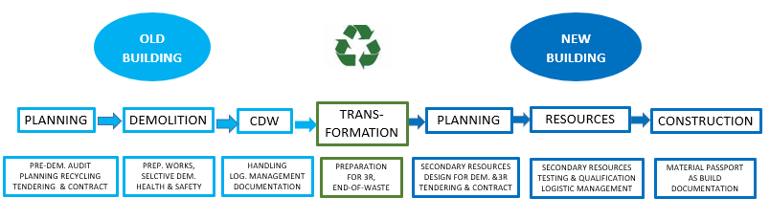
Figure 1 - Value chain of CityLoops. This guide on selective demolition is a tool for the demolition work based on the pre-demolition audit in planning element of the value chain.

Proposal for tool for selective demolition
This proposal comprises:
- Review of background and experiences of selective demolition in Denmark, Austria, Belgium, and other experiences.
- Framework for selective demolition.
- Guidelines for selective demolition
- Test and evaluation of the guidelines
The draft proposal is prepared by CRD in cooperation with the other partners of Tool no. 2. Høje Taastrup Municipality, Roskilde Municipality, City of Mikkeli, Miksei and Xamk.
Definitions and abbreviations are used in accordance with the CityLoops Project Glossary.
The term recycling is used in this document as a general term for reuse, recycling, recovery (3 R), utilization of CDW etc.

Development and experiences of selective demolition

Selective demolition in Denmark
From 1989 to 1991 the Danish Demolition Association carried out a comprehensive demonstration project for the purpose of defining selective demolition and associated activities. The aim was the development of a concept comprising standardized work schedules and the preparation of standardized plans for demolition sites including arrangement of containers and facilities for sorting of CDW.
Two demonstration projects were completed to test models for selective demolition. The projects included demolition of a residential building and three industrial buildings. Referring to presentation of the demonstration projects the results were following:
- It was estimated that 95% if all CDW in Denmark, excluding soil and asphalt, is potentially recyclable. Only 5% must either be incinerated or disposed of at a controlled disposal site or special treated.
- Selective demolition and sorting require approximately 30% more labour time and cost than conventional demolition and CDW dumping.
- Compared with conventional demolition and the magnitude of disposal fees selective demolition was 17.5% less expensive.
It was concluded that selective demolition can give rise to increased health and safety hazards because of additional manual labour work, which is involved in the sorting of materials on site.
On this basis an agreement on selective demolition was signed in 1996 by the Danish Demolition Association, member of the European Demolition Association (EDA), and the Minister of Environment and Energy on following conditions:
- The agreement comprised all demolition work and CDW handling of projects, where more than 10 t CDW was produced.
- Demolition work must be carried out as selective demolition in three phases as shown in table 1.
- The demolition contractor must ensure that minimum 80% of the total amount of CDW of the total amount of CDW produced in every demolition project is recycled according to a set of specific conditions. Maximum 5% of CDW must be dumped on controlled landfill.
- Demolition, handling, and disposal of CDW materials must be carried out in accordance with applicable laws and regulations.
- By the end of the demolition job the contractor must register the amounts of CDW and the distributions on fractions of materials. He must also report to the building owner about the transportation and the correct handover to a certified recipient/handler.
The agreement comprises specific requirements on environmental management, handling of hazardous materials, quality assurance & control and traditional legal conditions. Furthermore, the agreement has an independent control clause to ensure that the demolition contractors meet the provision of the agreement.
The agreement between the Danish Demolition Association and the Minister of Environment and Energy was approved by the Minister of Housing and published as a ministerial statutory order with effect for all public demolition contracts.
STAGES | ACTIVITIES
a) Removal of materials (stripping) | - Removal hazardous materials for special treatment  - Removal of movables and left items  - Removal of installations, doors, windows, and other materials
b) Demolition of structure | - Dismantling of roof-structure  - Demolition of bearing structure
c) Clearing of site | - Removal of foundations  - Removal of buried oil tanks  - Clearing of trees and bushes  - Cleaning and levelling of terrain
Table 1 -The three phases of selective demolition according to agreement between the Danish Demolition Association and the Danish Ministry of Environment and Energy, 1996.
After almost 25 years of application, the agreement is being revised. It is expected that the new version will focus on following key issues of selective demolition:
- Detailed guidelines for the performance of selective demolition.
- Requirements regarding the owner's obligation to prepare an environmental and resource plan (pre-demolition audit), as well as the requirement that the owner associates a trained environmental and resource coordinator.
- Approval scheme for companies carrying out demolition work and certification of staff.
According to the Danish Strategy of Circular Economy selective demolition is a key initiative. It is the intention of the Danish Environmental Protection Agency to make selective demolition mandatory. To assess the impact on the economy of implementation of selective demolition a social–economic study has been undertaken by Deloitte. The draft report shows a positive potential of the implementation of selective demolition in Denmark.

Austrian standard for dismantling of structures
The Austrian standard ÖNORM B3151 is mentioned as example of selective demolition in the EU waste management protocol and the EU pre-demolition guidelines, . The Austrian standard describes the measures required for project planning and execution of dismantling of structures and sets the principles for the separation of the individual materials with regard on recovery or disposal. The aim of the dismantling is to obtain pure waste fractions, that are as free as possible from pollutants and contaminants. This ÖNORM regulates the dismantling of buildings in civil engineering, including infrastructures and paved surfaces.

The norm defines dismantling as demolition of a structure or parts of a structure with the aim of generating construction and demolition waste to reuse, preparation for reuse or recycling. The separation of construction and demolition waste consider separation of the pollutant content, so that a mixing or contamination of the construction and demolition waste is minimized, and the escape of pollutants is prevented. The dismantling also includes activities such as reconstruction, renovation, refurbishment, repair, and construction work. The requirements for the standard procedure for dismantling where more than 100 t of construction and demolition waste, except for excavated material, are shown in figure 2.

The dismantling concept describes the type, scope, and organization of the dismantling. It regulates the tasks, measures, and areas of responsibility of those involved and the organization (including documentation) of dismantling in the different phases. The dismantling concept must be documented in accordance with a standard form (Appendix B in the norm) on behalf of the client before the dismantling (in Paper or electronic).

Pollutants, hazardous materials, or contaminants (Schadstoffe) and non-structural materials (Störstoffe), listed in table 2 and 3 must be removed before dismantling. Should there be any deviations, this must be justified in the dismantling concept.

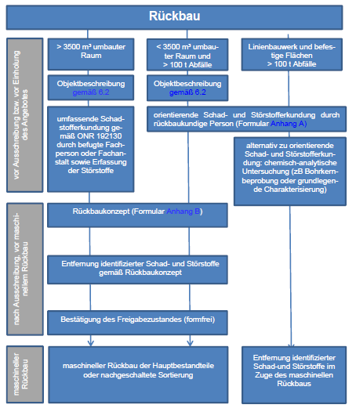
Figure 2 - Standard procedure for dismantling, ÖNORM B 3151, Appendix C. (text in German)

- Loose artificial mineral fiber (if hazardous)
- Components or parts containing mineral oil (such as an oil tank)
- Smoke detectors with radioactive components
- Industrial smokestacks (for ex., fireclay boxes, bricks, or lining)
- Insulating material made up of components containing Chlorofluorocarbon ((H)CFC) (like sandwich elements)
- Slags (for ex., slags in inserted ceilings)
- Oil-contaminated or otherwise contaminated soils
- Fire debris or otherwise contaminated debris
- Isolations containing polychlorinated biphenyl (PCB)
- Electrical properties or equipment with pollutants (for ex., vapor discharge lamps containing mercury, fluorescent tubes, energy-efficient lamps, capacitors containing PCB, other electrical equipment containing PCB, cables containing insulation liquids)
- Cooling liquid and insulations from cooling devices or air-conditioning units containing Chlorofluorocarbon ((H)CFC)
- Materials containing polycyclic aromatic hydrocarbon (PAH) (like tar bitumen, tar board, cork block, slags)
- Components containing or impregnated with salt, oil, tar, phenol (e.g. impregnated wood, cardboard, railway sleepers, masts)
- Material containing asbestos (for ex., asbestos cement, sprayed asbestos, night storage heaters, asbestos flooring)
- Other hazardous materials

Table 2 - List of CDW materials representing pollutants, hazardous materials, or contaminants (Schadstoffe) to be removed before dismantling according to ÖNORM B 3151.
- Stationary machines (e.g. building services), electrical appliances
- Floor constructions, double floor constructions
- Non-mineral floor or wall coverings (except wallpaper)
- Suspended ceilings
- Plaster covered installations (e.g. cables, cable ducts, sanitary facilities)
- Facade constructions and systems (e.g. curtain walls, glass facades, thermal insulation)
- Seals (e.g. bitumen cardboard, plastic films)
- Building materials containing gypsum (e.g. gypsum plasterboards, gypsum planks, gypsum-containing flowing screeds), except gypsum-containing wall and ceiling plasters and gypsum-containing composite screeds
- Partitions made of cork, aerated concrete, cement-bound wood wool panels, wood, plastic, glass, glass walls, walls made of glass bricks
- Loose mineral wool, glass wool and other insulation materials, except impact sound insulation
- Doors and windows (except for those that serve as dust protection when demolished),
- Plants and soil (e.g. from green flat roofs)

Table 3 - List of CDW materials representing non-structural materials (Störstoffe) to be removed before dismantling and demolition of the bearing shell structure of the building according to ÖNORM B 3151.

TRACIMAT – traceability system for waste recycling
TRACIMAT, a non-profit CDW management organization was founded by the EU project HISER partner - the Flemish Construction Confederation, together with the Federation of Producers of Recycling Granulates, the Belgian Demolition Association and the Organization representing the engineering and consultancy companies.

The TRACIMAT traceability system covers the following elements:
- Pre-demolition inventory.
- Monitoring and supervision of flows.
- Certification system for the construction and demolition material from selective demolition to be accepted as low environmental risk material.

TRACIMAT certifies the selective demolition, thereby assuring the processing company of the quality of the construction and demolition waste. Through an elaborate traceability system TRACIMAT monitors and supervises the selective demolition process. The tracking procedure starts with an identification of the materials that come free during the deconstruction and demolition of the building and follows up on what happens with these materials during the selective demolition works. Environmental risks during deconstruction and demolition will consequently be limited, hazardous waste materials will be correctly and –more importantly – safely removed, which will result in purer waste stream. Based on intermediate inspections at demolition sites and desk control of the discharge certificates/processing documents, TRACIMAT will check if its traceability system has been applied correctly and will deliver the necessary documents and certificates.

TRACIMAT issues certificate of selective demolition for construction and demolition waste that has been selectively collected and subsequently gone through a tracing system. The demolition certificate tells the processor whether the demolition waste can be accepted as low environmental risk material and therefore be processed separately from waste streams with a high environmental risk. Purer waste streams with a low environmental risk clearly have a greater upcycling potential. This in turn opens opportunities for incorporation into more high-quality applications than are possible today. The demolition waste comes with a certificate issued by a recognized and independent organization, which will enhance trust not only in the quality of the material, but also in the quality of the demolishing company. It will also boost trust in the recycled product, resulting in improved and more widespread marketing of recycled granulates.
TRACIMAT will not issue a certificate of selective demolition until the waste has gone through a traceability system. The tracing process starts with the preparation of a destructive demolition inventory and waste management plan prepared by an expert prior to the selective demolition and dismantling work. To guarantee the quality of the demolition inventory and waste management plan, they must be prepared according to a specific procedure. TRACIMAT will check the quality of the demolition inventory and waste management plan and issue a declaration on its conformity. Based on intermediate inspections at construction sites and desk control of the discharge certificates/processing documents, TRACIMAT checks whether both the hazardous waste and the non-hazardous waste that complicates the recycling of the specific construction and demolition material, have been selectively and properly disposed of.
TRACIMAT will initially focus on the stony fraction, which in terms of weight by far represents the greatest portion of the construction and demolition waste. Where possible, the organization’s field of activity will be expanded in the future to include other types of construction and demolition waste materials.
An important part of the TRACIMAT traceability system is the training of auditors. The TRACIMAT system was compared to a business-as-usual practice in the EU HISER project. The conclusions were following: a TRACIMAT supported case leads to a significant decrease of 7–14 per cent in the potential impact in some environmental categories. The impact in the environmental categories was acidification, 14 per cent; terrestrial eutrophication, 10 per cent; marine eutrophication, 7 per cent; and photochemical ozone depletion, 7per cent; all based on product environmental footprint calculations.

Traditional vs. selective demolition, Portugal
A comparative economic analysis of traditional versus selective demolition has been carried out in Portugal. The case study refers to an urban renewal project named Cacém Polis (Phase 2), located within Lisbon outskirts. It has involved the removal of several townhouses built between 1900 and 1945, of low to average building quality, in an average of about 100 m² per house, within a total of 13.430 m² of removed gross floor area.
The demolition/deconstruction activities were conducted by a specialized company, well familiar with such operations. However, to optimize costs, the chosen removal method was a mixed one, including an initial soft stripping activity, followed by a traditional demolition of the remaining materials, over which (already at ground level, working around the resulting mixed pile) some valuable items were recovered, mainly wood and metallic (iron and steel) elements. Soft stripping refers to the selective recovering of removable elements and surface materials such as floor coverings, ceiling plaster, wood surfaces, doors, windows, furniture, bathroom fixtures and wooden stairs.

The resulting mass composed mostly by stone, ceramic and concrete blocks, shingles, mixed with small and pieces of other materials (elements like plumbing (mostly ceramic and lead) and electrical wiring (mostly plastic and copper)), was then transported to a dedicated landfill, where a simple crushing activity was performed. All other materials (recovered from the soft stripping and pile scavenging activities) were separated and sent to recycling operators. The work was conducted in a traditional demolition labour hierarchy, with regular non-specialized workers to perform the stripping and the scavenging, equipment operators to manoeuvre the excavator and the loaders and supervisors to address the technical and security overview of the works. As far as this paper is concerned, the terms selective demolition and deconstruction will be used alternatively, as equivalent denominations.
From the present case study analysis, following conclusions are drawn:
- Although an average based scenario gives economical preference to traditional demolition over selective demolition, it is possible to achieve lower global costs for the latter, especially when mixed CDW disposal costs are particularly high (when compared to other scenarios).
- The traditional demolition costs are very much dependent on the final disposal cost (of mixed CDW), while selective demolition cost structure is more levelled between labour, equipment, transport, and final disposal costs.
- To be able to sell out (or at least reuse on the site or in other works), even at a low price, the total or partial bulk mass of “clean” aggregates, will certainly turn many presently uneconomical selective demolition projects into viable ones.
- To enhance the mechanization (equipment operation) of deconstruction activities, shortening schedules and cutting labour costs, maintaining high recovery rates is possible and desirable, although it needs to be adapted to each type of building.
- Whenever possible, materials shall be recovered in a good enough condition to be reused, putting efforts into the commercial activity of selling those materials to guarantee a cost/revenue ratio as low as possible for each recovered material. Recycling, although positive in environmental terms and effectively diverting materials from landfill, may not be enough to gain an economical edge over traditional demolition: it may be necessary (and most of the time, preferable) to search for actual revenue from selling materials and not only cutting costs in final disposal.
- The total labour costs are considerably higher in deconstruction activities than in traditional demolition (about 6 times more, in this case), as well as time needed to complete the work.

Framework for selective demolition

Concept
As mentioned in the presentation of selective demolition in section 1.2 the ETC report Construction and Demolition Waste: challenges and opportunities in a circular economy highlights selective demolition by the end of buildings life phase as a key concept for improving circular economy in the construction sector. See box 2.ine
box 2 – CONCEPT OF SELECTED DEMOLITIONheading
The overall aim of selective demolition, based on information from the pre-demolition audit, is to recover high-quality (pure) material fractions for recycling or reuse. The purpose of such an audit is to identify hazardous materials that must be removed prior to demolition and assess the recycling potential. The selective demolition is followed by the processing of the material fractions to ensure high-quality recovery. Selective demolition does not reduce the total amount of waste generated but enables the recovery of fractions for high-quality recycling.

The concept of selected demolition, which is expected to be implemented in the CityLoops demonstration projects, especially Mikkeli, Bodø, Roskilde and Høje Taastrup comprises following conditions:
- Selective demolition is implemented in all demolition projects of CityLoops demonstration projects as an integrated element of the CityLoops value chain, see figure 1.
- Planning of demolition projects are based on pre-audit screening and assessment of hazardous waste and materials in accordance with the CityLoops screening procedures and guidelines (PDA Guide).
- Tendering and contracts of demolition projects must include specified requirements for the sequence of selective demolition and sorting CDW on-site. Selection criteria must include quality of selective demolition and CDW management.
- Traceability of all fraction CDW must be ensured by complete documentation of the material flow from demolition to transformation.
- A quality management system including quality assurance and quality control must be established to ensure the performance of selective demolition and the CDW management.
- The extra cost of selective demolition compared to traditional demolition should be compensated by saving cost of CDW management and income from the sale of recycled materials.

Demolition process
Demolition is the first element of the CityLoops value chain shown in figure 1. In principle the demolition process comprises three phases as shown in more in figure 3. Sometimes the cleansing and decontamination is performed as a separate work under a contract separated from the demolition contract.
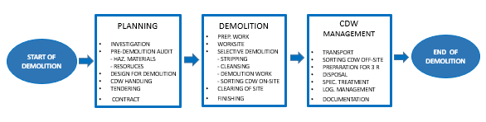
Figure 3 - The phases and main activities of the demolition process. The activities of the demolition process include selective demolition.
The key issue of selective demolition is the sequence of on-site sorting and demolition. Referring to Danish and Austrian experiences the selective demolition should be conducted in minimum three stages, presented in table 4. Depending on the actual circumstances and conditions more stages. For instance, this is the case for projects with much inventory and covering of walls, floors, and ceilings, which need to be removed before decontamination of the interior of the building can take place.
The initial removal of garbage left items, furniture, installations etc. and stripping of surface covering materials is often called soft stripping.
The demolition contractor must follow specified requirements of work to meet the owner’s objectives of circular economy and recycling materials based on experiences mentioned in chapter 2 and requirements of handling and sorting the individual CDW fractions. Selective demolition is more time consuming than traditional demolition. Furthermore, selective demolition needs more work by hand than traditional demolition. This leads to a higher degree of risk to workers health & safety.
Sorting of CDW on-site depends on requirements for selective demolition. Sorting CDW, weather we are talking sorting on-site or off-site, depends on national legislation and the market for recycled materials. The term “market” is very general. Most countries have various types of market for recycled materials, on-line marketplaces, physical places for sale of recycled doors, windows, bricks etc. Usually, the sale of recycled materials is not integrated in the general market of building materials. However, the integration of marketing recycled materials in the normal market for building materials should be an ambitious goal for circle economy in the building sector.
Fractions according to European Waste Code (EWC 17 Construction and Demolition Waste) and typical handling is presented in table 5.
STAGES | ACTIVITIES | COMMENTS
a) Removal of materials (stripping) | - Removal of movables, garbage, furniture, and left items.  - Removal of hazardous material (see table 2) and preparing for decommissioning.  - Removal of interior materials (see table 3) installations, doors, windows, tiles, roof construction, insulation in walls etc. | - Take care of animal waste, needles used for drugs etc.  - Eventually marking of owners left property.  - In some cases, doors and windows are needed for keeping interior pressor for decontamination.  - Generally, handwork, focus on H&S.  - Quality check of clean and stripped structure.
b) Demolition of structure | - Dismantling of roof-structure  - Demolition of bearing structure  - Removal of foundations | - Demolition from top.  - Generally, machine work, focus on risk and safety.  - Main fractions concrete, masonry, wood, and steel must be separated.  - Quality check of removal of all structures.
c) Clearing of site | - Removal of buried oil tanks  - Clearing of trees and bushes  - Cleaning and levelling of terrain  - Finishing | - Eventually care of trees to be saved.  - Filling and levelling with recycled materials.  - Quality check of site.
Table 4 - The three phases of selective demolition according to Danish and Austrian experiences (table no. 1-3).
Referring to ETC report on CDW Challenges and opportunities, selective demolition is closely linked to waste sorting requirements. In for example Belgium, Denmark, Finland, and Sweden there are legal requirements for sorting different waste fractions. This means that the waste must be separated at the demolition site, although in all four countries there is a possibility of allowing mixed construction waste to be sorted at special facility. Legal requirements for sorting CDW in Denmark Finland and Sweden are presented in table 6.
Beside legal requirements of sorting, the requirements of selective demolition and sorting on-site depends on the opportunities of circular economy, including opportunities for transformation and marketing the CDW materials. Table 7 presents a list of typical CDW materials and related opportunities for recycling according to the EU waste hierarchy. The list includes requirements of demolition and handling on-site. With respect to circular economy, the general objective is recycling CDW on highest/optimal level of the recycling-ladder, which means reuse of the materials. However, this is presupposed environmental and economic feasibility which require:
- A professional market for recycled materials/secondary resources.
- Opportunities for local recycling and short transport distances for transformation of recycled materials.

EWC CODE 17 | WASTE MATERIAL FRACTIONS | BUILDING / STRUCTURAL MEMBER | TYPICAL HANDLING PROCESS
1701 | Concrete, bricks, tiles and ceramics. | Foundation, bearing structure, internal walls, and slabs. | Crushing and recycling, substituting natural materials.
1702 | Wood, glass, and plastics. | Roof, floors, doors and windows, membranes, covering. | Somewhat reuse of wood, doors, and windows, recovering of glass, plane glass and plastics.
1703 | Bituminous mixtures, coal tar and tarred products. | Roof and surfaces. | Recovering, special treatment.
1704 | Metals (including their alloys). | Structural steel in bearing structure, reinforcement, pipes, installations etc. | Recovering of metal and iron and other not hazardous metals.
1705 | Soil (including excavating soil from contaminated sites), stones and dredging soil. | Foundations and filling around the structure. | Reuse of clean soil, cleansing and recovery of soil containing hazardous substances.
1706 | Insulation materials and asbestos-containing construction materials. | Insulation in facades, roof, heating and cooling installations etc. | Reuse and recovering of not-hazardous materials. Special treatment of hazardous materials. disposal of asbestos materials.
1708 | Gypsum-based construction material. | Partition walls, covering plates. | Reuse of plates, recovery of gypsum.
1709 | Other Construction and demolition wastes. | All kind of structures, painted materials etc. containing hazardous substances. | Cleansing, recovering, special treatment and disposal.
Table 5 - In the process of selective demolition, the CDW may be sorted into materials fractions including soil and asphalt for handling. The table presents example of list according to European Waste Code (EWC 17 Construction and Demolition Wastes) and typical handling .

CDW FRACTION | DENMARK | FINLAND | SWEDEN
Brick/tiles | X | X | X
Concrete | X | X | X
Glass | X | X
Gypsum | X | X | X
Insulation | X |  | X
Mixed stony fraction | X | X
Mixed concrete and asphalt | X
Paper | X | X
Cardboard | X
Plastics | X | X | X
Polyvinyl chloride (PVC) | X | X
Scrap metal | X | X | X
Stone materials, e.g. granite | X | X
Tiles and ceramics | X |  | X
Wood | X | X | X
Table 6 - Legal requirements or recommendations for material-specific separation of CDW in
Nordic countries. Reference ETC report and input from Xamk (Mikkeli).
CDW FRACTION | PREP. REUSE | RECYCLING | RECOVERY | 4.  DISPOSAL | COMMENTS
Concrete | Concrete elements and structures. Careful dismantling. | Crushed concrete, for aggregate in new concrete or unbound road materials. | Crushed concrete for backfill.  Fines 0-4 mm from crushing. | Fines 0-4 mm from crushing. | Crushed concrete must be pre-crushed on-site, max. size typical 400 mm.
Masonry | Reuse of bricks and roof tiles.  Careful dismantling and handling. | Crushed masonry for road materials. | Crushed masonry for backfill. | Plaster and mortar from masonry.
Wood | Reuse of timber.  Reuse of doors and window frames. | Shredding for chip boards etc. | Shredding for landscaping.  Incineration.
Metal | Reuse of construction steel. | Scrap iron and metals. Melting at steelwork. |  |  | Traditional handling of scrap materials.
Glass | Reuse of windows and plane glasses. |  | Melting for new glass or insulation materials. | Poor, dirty glass. | Recycling and recovery of glass need careful cleaning.
Gypsum | Reuse of cardboards. | Recycling of gypsum. | Recovery for other purposes. | All kinds of gypsum.
Table 7 - Typical CDW materials and related opportunities for recycling according to the EU waste hierarchy. The list includes requirements of demolition and handling on-site.

ACTIVITY |  | TRADITIONAL DEMOLITION | SELECTIVE DEMOLITION
PLANNING
Investigation | Basic investigation by the owner. Detailed investigation by the contractor. |  | Detailed investigation by the owner.
Pre-demolition audit | Hazardous material audit by the owner. Basic assessment of CDW by the contractor. No specific assessment of materials and resources. |  | Audit of hazardous materials and resources by the owner. Assessment of opportunities for recycling, transformation, and use of recycled materials in new buildings.
Design for demolition | Contractor. |  | Selective demolition design by the owner.
Tendering | Based on basic information  Price and time criteria. |  | Based on detailed information.  Detailed work description (selective demolition)  Price, quality, and environmental impact criteria.
Contract | Basic conditions. |  | Detailed condition, eventually recycling options.
DEMOLITION
Preparation work | Common activities depending on the actual circumstances. |  | Common activities depending on the actual circumstances.
Worksite | Minimum sufficient area and facilities. |  | Extended area for containers and stockpiling sorted CDW.  Facilities for sorting and downsizing materials.
Stripping | Removal of things and installations to the extent necessary. |  | Complete removal of things and installations.
Cleansing  Decontaminating | According to national guidelines and threshold values for hazardous waste handling. |  | According to national guidelines and threshold values for hazardous waste handling.
Demolition work | Mainly machine efforts from the ground.  No workers on the structure.  Focus on economy. |  | Selective demolition stripping and dismantling. Demolition top-down. Focus on circular economy.  Much handwork and more risk to workers than traditional demolition
Sorting CDW on-site | Minimum sorting. High proportion of mixed waste. |  | Sorting in specific fractions. Minimum mixed waste.
Clearing of site | According to actual conditions. |  | According to actual conditions. Recycled materials for levelling the ground.
Finishing | According to actual conditions. |  | According to actual conditions.
CDW management
Transport | Contractors choice. |  | Minimum transportation
Sorting off-site | Contractors choice. |  | Only the extent necessary sorting off-site.
Disposal | Contractors choice. |  | Minimum disposal.
Special treatment | According to legislation and rules. |  | According to legislation.
Logistic management | Contractors responsibility |  | Contractors responsibility according to directive of owner. Minimizing transport by local recycling.
Documentation | Minimum, according to legislation and guidelines. |  | Documentation on traceability, quality, and handling.
Table 8 - Comparison of activities of traditional demolition and selective demolition according to activities, see figure 3.

Characteristics of selective demolition
Referring to the presentation of selective demolition in section 1.2 and the experiences in chapter 2, selective demolition is planned and designed much more detailed than demolition projects in the past – called traditional demolition. Compared with traditional demolition selective demolition has several characteristics, which are summarized and presented in table 8 referring to the demolition process in figure 3. A key aspect of proper CDW management is to keep materials separated including fixation materials. Improved collection of goods for re-use and recycling requires selective demolition and appropriate on-site operations as well. The better inert CDW is separated, the more effective recycling will be and the higher the quality of recycled aggregates and materials. However, the degree of separation depends strongly on the options available at the site (e.g. space and labour) and on the costs and revenues of separated materials. Such separation can be challenging. Buildings have become increasingly complex and this has implications for demolition works. Furthermore, over the last few decades, an increasing amount of materials have been glued and the use of composite materials has extended as well.
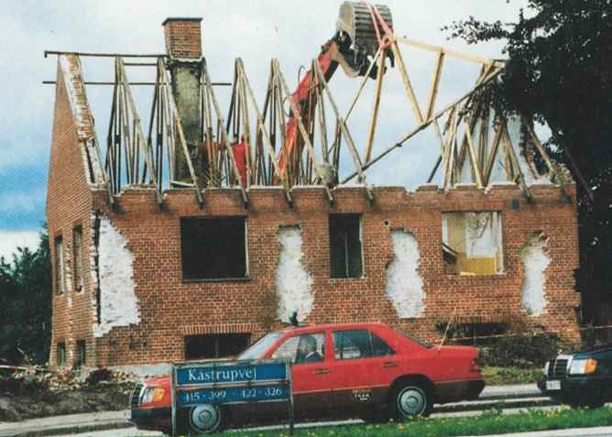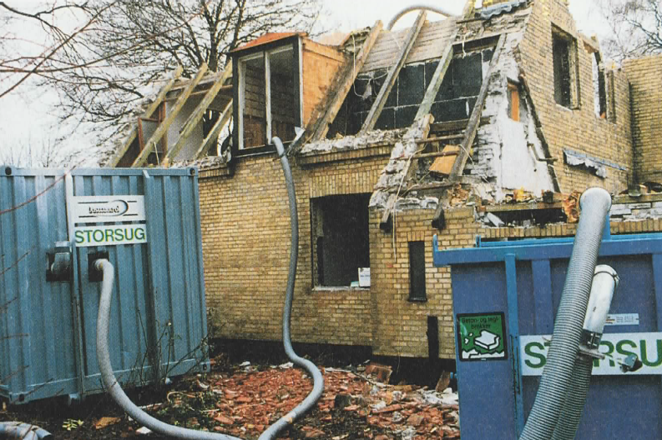
Figure 4 - Selective demolition of buildings 1992. The photo left shows masonry walls after removal of insulating materials and dismantling of roof structure. The photo right shows removal of loose materials, wallpaper etc by use of a big industrial vacuum cleaner. The demolition project comprised demolition of approximately 700 small houses for the land structure of the Øresund Link between Denmark and Sweden 1992-1995. 100.000 bricks were reused in a new compartment building in Copenhagen.
The overall challenges of demolition projects in general are money and time. Selective demolition takes more time and is more expensive than traditional demolition. The most important prerequisites for selective demolition and steps towards green change, CO₂ reduction, and circular economy are following:
- Establishment of a regular market for recycled/secondary building materials.
- Sufficient facilities for CDW management and transformation of CDW to building materials.
- Appropriate legislation and instruments for sorting materials, promotion of recycling and circular economy.
- Information and education.
- Owners commitment and willingness to pay for quality.
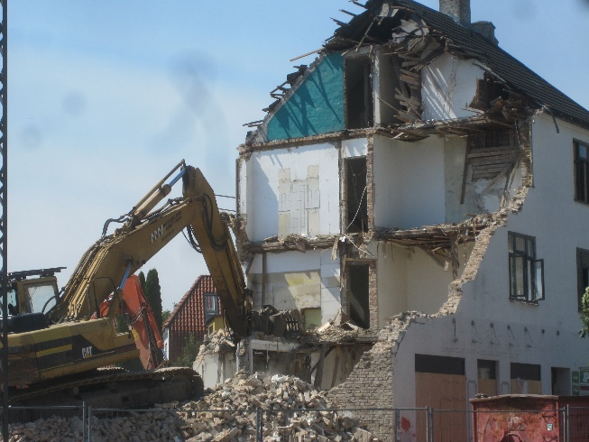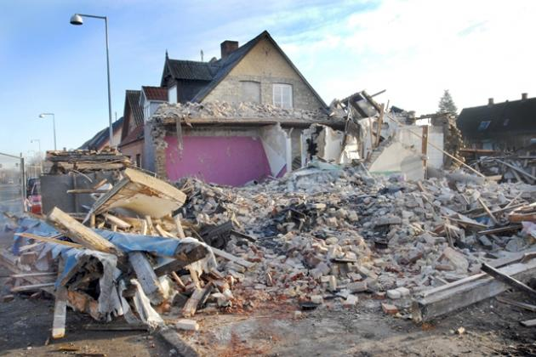
Figure 5 - Traditional demolition of buildings 2017. Despite the introduction of selective demolition, traditional demolition without any on-site sorting is often seen in Denmark.
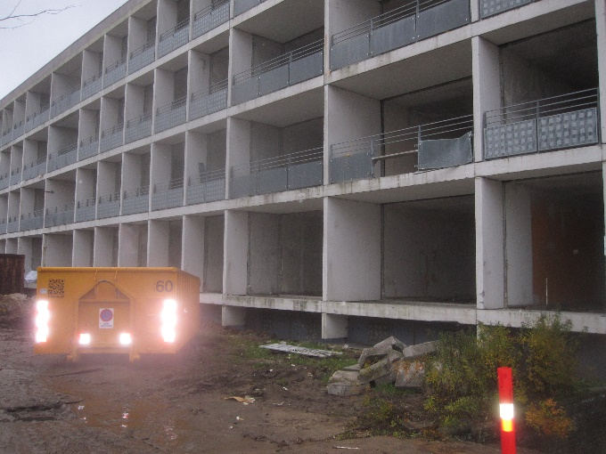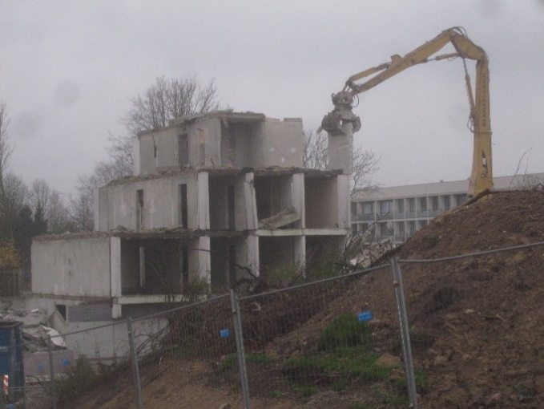
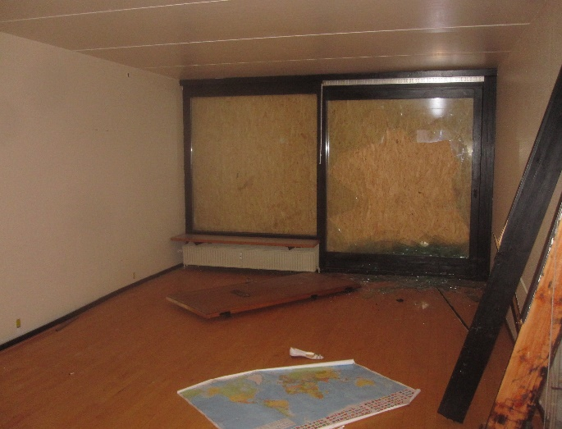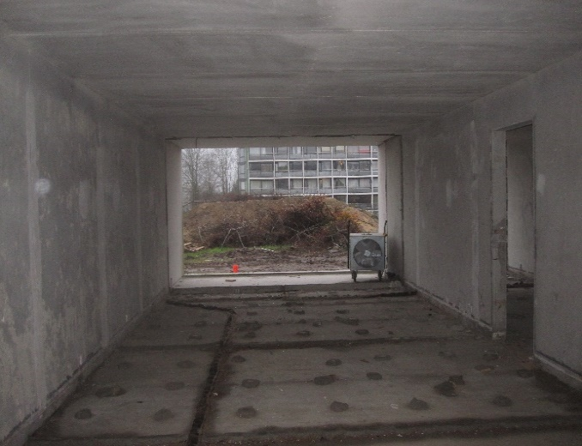
Figure 6 - Demolition of exposed residential building in Gellerupparken, Aarhus, 2015. The building is total stripped for interior materials and cleansed for contamination of PCB before demolition. After crushing on site all concrete materials are recycled and sold by the contractor.

In 1992 the public owned Øresund Link Company contributed to the implementation of selected demolition in Denmark for preparing the construction of the combined bridge and tunnel cross way from Copenhagen, Denmark, to Malmo, Sweden. Figure 4 shows selective demolition of some of the first buildings to be demolished.
Although Denmark in 1996 introduced selective demolition as mandatory for public developers, traditional demolition is still widespread in Denmark. Figure 5 shows recent examples of traditional demolition mixing CDW. However, this kind of demolition is decreasing. Today the normal style of demolition is selective demolition, including total cleansing of buildings before demolition of main structures as seen in figure 6, demolition of social exposed residential buildings in Gellerupparken, Aarhus.

Drivers and barriers for selective demolition
The term selectiv demolition is a general term which is often used based on an elastic perception of requirements for sorting. Introduction and implementation of selective demolition in demolition contracts need specification of sorting CDW, work processes, especially sequences of work processes and expected output of the sorting related to objectives of recycling CDW and circular economy. The requirements of selective demolition and degree of sorting depends on time and money. The requirements of selective demolition must be based on national/regional legislation and balanced with the actual conditions. Inspired by the ETC report a list of drivers and barriers for selective demolition is presented. In table 9.
CHARACTERISTICS | DRIVERS / BENEFITS | BARRIERS / CHALLENGES
Legislation | Selective demolition is mandatory.  Specific provisions for sorting CDW and separation of hazardous materials.  Incentives and instruments for resource management, recycling CDW and circular economy are introduced. | No demand for selective demolition.  No specific characteristics of selective demolition.  Requirements for time, cost and health and safety more demanding than selective demolition.
Market/economics | Higher value for CDW fractions.  Transformation costs are lower following selective demolition.  Creation of more jobs.  Early planning and selective demolition improve matching CDW and demand for construction materials (circular economy) | Selective demolition requires detailed and proactive planning of transformation of CDW to resources.  More labour time and cost.  The total cost of selective demolition is difficult to determine.  Low cost of natural resources.
Quality | Use of efficient selective dismantling enables separation of fractions, especially unwanted fractions from recyclable CDW, and improve quality and opportunity for recycling. | Cost and time are prioritized.  Demands for quality must be specified.
Local conditions | Improved opportunities for local recycling and direct reuse. | Short distance to local landfills and low tipping cost.  Sensitive environment (dust, noise, vibration) hamper recycling processes.  Lack of space on demolition site for containers and stockpiling sorted CDW.
Construction to be demolished | Complete information on material and construction, eventually material passport, facilitates pre-demolition audit and planning selective demolition.  Design for disassembly promotes selective demolition, | Lack of drawings and information of the building to be demolished hamper the selective demolition.  Complex buildings increase cost and time for selective demolition and material separation.  Integrated building elements, e.g. sandwich elements need of-site separation and treatment.
Technological development | New techniques for material recognition and detection hazardous substance.  Development of robot technologies | Need for hand work require workers on the structure exposed to health and safety hazards.  Lack of information cause surprises and unintended mixing CDW
Information and education | Recycling of CDW and circular economy is common knowledge in the building and construction industry.  Education of demolition, recycling, and circular economy at all relevant levels.  Certification of managers and specialists. | Several stakeholders involved in the value chain (see figure 1) are challenged with understanding and experience.
Dialogue and communication | All stakeholders involved in the value chain (see figure 1) understand the meaning of dialogue and communication.
Quality assurance | Quality assurance systems are implemented.  Traceability of CDW streams from demolition, transformation to use is mandatory.  The material flow and processes are fully documented. | Detailed documentation of CDW and recycled materials through the value chain (see figure 1) is challenging.
Table 9 - List of drivers and barriers for selective demolition, according to the ETC report 2020.

Guidelines for selective demolition
Implementation of selective demolition in urban development as well as specific demolition projects in CityLoops demonstration projects depends on the actual situation and conditions for the projects. Based on the framework and concept for selective demolition, presented in chapter 3 and the CityLoops Guide for Pre-demolition Audit (PDA Guide) following guidelines are proposed.

Planning
Planning comprises all activities from the owner’s decision about of the demolition of a building to entering the contract on the demolition work. The planning comprises typical following activities:
- Investigation
- Pre-demolition audit
- Design for demolition
- CDW handling
- Tendering and contract

Investigation
The demolition project starts with desk study and collection of information, including:
- History and use of the building
- Technical drawings, plans and details
- Geographical information, photos, drones, Google Earth review
- Public information on urban planning, pollution, restrictions, traffic, formation on neighbours etc.
Based on the initial desk study it is recommended to make an overview and scope of work including a rough assessment of the pollution of the building, total amount of CDW, complexity of the structure, and method for demolition. A rough budget of time and cost should be prepared. A model of the processes to be elaborated during design for demolition like the example of a model of selective demolition shown in in figure 7, is useful. Field study and detailed examination of the building take place (see PDA Guide chapter 6) followed by pre-demolition audit.

Pre-demolition audit
Pre-demolition audit to be conducted in accordance with the PDA Guide. The screening procedures comprise:
- Hazardous waste materials in the building to specify the decontamination work and separation of polluted materials from clean recyclable materials. The Hazardous waste report shall form the background for the decontamination of the structure before demolition to ensure un-polluted/clean CDW materials. The screening of hazardous materials and assessment of decontamination is based on national member state regulation and practice.

- Materials in the building to specify the amount and types of CDW and resources and the management of the materials. Fractions of materials according to national/local requirements. The Material report shall form the background of planning the selective demolition, optimization of recycling the materials in structures, and handling of materials.

Because of different skills of monitors the screening often takes place as two separate field studies of the building structure and reported systematically using Excel sheets like the Finnish guideline example. It is presupposed that the two types of screening are performed of certified/qualified specialists.
The pre-demolition audit might be carried out in two or more steps (see PDA Guide chapter 4) starting with initial screenings to create overview of the pollution and the materials followed by detailed technical investigations to decide the pollution and quality of the materials. For instance, recycling concrete to crushed aggregates in new concrete need sampling and laboratory analyses of the concrete before demolition.

Design for demolition
Design for demolition depends on the structure to be demolished and the requirements of selective demolition. Traditionally, in case of a simple un-complicated structure and no specific requirements to demolition methods or CDW handling, the demolition contractor is responsible for design of demolition. In case of a complex structure or critical risk and safety issues, or specific requirements for CDW handling, the building owner might take the responsibility for technical design of selective demolition.
The design comprises:
- Description of phases to optimize sorting
- List of CDW fractions to be sorted
- Conditions for sorting
- Design of dismantling/demolition methods
- Health & safety precautions and risk reduction.,
Depending on the condition of the building, e.g. in case of how long time the building since taken out of use, number and types of left items, amount of accumulated garbage, haunt for homeless etc. it might be feasible to start the demolition with soft stripping to prepare decontamination inside the building. Decontamination will be followed by stripping of fixed items and all other materials except the main bearing structure of the building. The second stripping phase is followed by demolition of main structure and clearing of the site.
Based on the pre-demolition audit a list of CDW fractions and conditions for sorting out each fraction with respect to the actual opportunities for recycling is prepared (see table 5 and 7, and PDA Guide Annex 2).
The design og dismantling/demolition methods aims on applicable demolition techniques, separation of materials and safety. In case of demolition of masonry walls aiming on recycling bricks it is important that the machines manoeuvres take care of the bricks and avoid damaging the brick under the belts of the machines.
The design of demolition must ensure that the stability of the structurer is safe during the work and risk of unplanned collapses are minimized.
Compared with traditional demolition selective demolition is characterized by a high proportion of handwork. Therefore, the design of demolition must entail detailed planning of safety precautions and risk reduction means.

CDW handling
Based on the pre-demolition audit the CDW handling is planned. The CDW handling depends on the member state waste legalization and the actual local opportunities to handle and recycle the various types of CDW. Usually, the demolition contractor is responsible for planning and management of handling CDW. However, the owner might see opportunities for special agreements on disposal or special treatments of hazardous materials or agreements on sale of recycled materials to be used in new building projects, e.g. sale of reused bricks of crushed concrete. Often, the owner has more time to find optimized/cheap CDW solutions.
Usually, the ownership of all materials in the building and the construction is transferred to the demolition contractor by the day of the start of the contract. Unless otherwise indicated, CDW becomes the property of the contractor. Property of the owner must be marked and handled according to the contract.

Tendering and contract
Tendering and contract are performed in accordance with common EU and member state procedures for procurement within the building- and construction sector. Usually, selective demolition contracts will comprise more detailed description and requirements of sorting CDW, demolition and handling CDW than traditional demolition contracts.

The tender documents comprise a set of documents, typical:
- Call for tender with presentation of the project and key issues of the contract.
- Conditions for submission of bid, including specified selection criteria and evaluation procedure.
- Work description – Scope of work
- Annexes comprising technical information, drawings, pre-demolition audit reports, investigation reports and other documents.

The tender documents should comprise all available details on the project. The call and condition should disclose the owner´s politics on sustainability and circular economy, and his requirements of circular economy and selective demolition. The work description should comprise description a clear and short presentation of selective demolition and the requested phases and work processes, including list of items and materials to be removed in each phase. Furthermore, the work description should specify the handling, see table 8.

Demolition
The demolition contractor must follow specified requirements of work to meet the owner’s objectives of circular economy and recycling materials based on experiences mentioned in chapter 2 and requirements of handling and sorting the individual CDW fractions. The typical demolition process comprises:
- Preparatory works
- Establishment of work site
- Selective demolition:
- Soft stripping
- Cleansing / decontaminating
- Stripping / Dismantling
- Demolition of main structures
- Sorting CDW on site
- Clearing of site and finishing

Preparatory works
Preparation of work comprises for instance cutting, change and restructuring of utilities (water, sewer, heat, power, cabling etc.) change of traffic, traffic restrictions and other measures of local regards. Some of the works might be done before the start of demolition contract, and other works might be a part of the contract.
The preparatory works comprises means for protection the environment against dust, noise, and vibration, e.g. protection of neighbour’s windows, ventilation system, and shock insulation of sensitive equipment. In dense population and sensitive environment, it might be necessary to protect the environment and conduct the demolition work under complete cover. This might also protect the demolition workers against weather conditions.

Worksite
Preparation of worksite comprises establishment of enclosure and securing the site, gateways, work sheds and facilities for decontamination. In case of selective demolition ample space for placing containers for sorted CDW and temporary stockpiling soil, concrete and brickwork. Space for depot for reusable items and initial preparing CDW for recycling, e.g. pre-crushing of concrete and separation of sandwich element, might be required.

Selective demolition
The demolition work performed as selective demolition comprises stripping, cleansing / decontamination, demolition, and sorting CDW presented in figure 7. Depending on the job and the object to be demolished the stripping activities must be coordinated with the cleansing work. Usually, it is normal practice to give the demolition contractor free choice of demolition methods. Therefore, it is important that the selective demolition should be flexible, based on dialogue and mutual understanding among the parties.
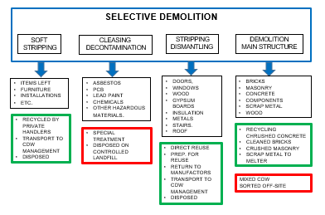
Figure 7 - Example of selective demolition processes with four steps of selective demolition. The figure shows the sorting of typical materials and their handling. The green boxes indicate materials for reuse, recycling, and recovering. The red boxes indicate Hazardous waste to be special handled or disposed of, and mixed CDW which is not sorted on site. Cleansing / decontamination.

Soft stripping
Soft stripping is the start of the work, which includes removal of all loose items: Furniture, garbage, carpets, loose panels, cover plates etc. Items belonging to the owner or items sold to other parties must be marked and removed in accordance with the conditions of the contract. The soft stripping facilitates free access to polluted areas, components, and installations for decontamination. Some of the removed items might be polluted and require special handling.

Cleansing / decontamination
Cleansing of contaminated parts of the object before demolition take place in accordance with the pre-demolition screening of hazardous materials and the specified requirements of the work and handling of hazardous waste. Se list of the Austrian ÖNORM B 3151, table 3. Specifications of the cleansing work and handling hazardous waste materials follow member state´s national legislation and rules for threshold limits, workers health and safety, environmental protection etc. for handling asbestos and lead in painted surfaces.
Insulated vacuum tight work cells are established for removal of hazardous materials in walls, floors etc. In some cases, the total building is sealed and tightened. Therefore, removal of doors and windows must await completion of the decontamination work.
Cleansing of PCB polluted structures might cause major structural interventions by cutting out polluted concrete close to PCB-contaminated joints. Therefore, the contractor must ensure that no risk to the bearing capacity of the structure occurs.

Stripping / dismantling
After decontamination all non-bearing installations, electrical installations, heating installations, doors and windows, toilet and sanitation etc. are removed. Se list of the Austrian standard ÖNORM B 3151. table 4.
The soft stripping and the dismantling are mainly hand work with assistance of small loaders, excavators and cranes. The contractor must ensure that no dismantling work compromises the bearing capacity of the remaining structure and expose the workers to any risk of hazards.
It is necessary to define the product of the stripping processes and specify the results and quality. For instance, removal of wall, floor- and wall tiles in bathrooms, removal of installations fixed in the structure etc.

Demolition of main structure
When the cleansing, decontamination and stripping processes are completed the main structure is demolished from top to ground. This work is normally carried out by use of demolition machines operated outside the structure.
In case of demolition of masonry where the bricks are intended to be reused special precautions must be taken to ensure undamaging the bricks. The dismantling work must be performed gently and driving in fallen rubble must be avoided.

Sorting CDW on site
CDW materials are sorted on the demolition site in fractions according to the materials in the demolition object and the planned handling as indicated in table 8 and figure 7. Concrete rubbles for crushing and recycling in unbound bearing layers and concrete rubbles for crushing and recycling as aggregate in new concrete must be separated. If used as aggregate in new concrete handling and storage must ensure that sorted concrete is not contaminated with soil. Timber for reuse must be gently treated, cleaned, and stored properly, wood for incineration and wood for shredding and recycling must be separated etc.
Reinforcement bars, structural steel and steel pipes, electric cables and other installations integrated in the building structure must be recovered during the demolition process and sorted in respective fractions.
In case of building complicated structures, integrated façade elements, sandwich-elements, and other similar structures, which, for reasons of time and opportunity, are not appropriate to disassemble at the demolition site, are removed to sorting and treatment externally.

Clearing of site and finishing
After completion of demolition and removal of all materials the site must be cleaned, and the terrain levelled according to the specifications. This includes backfilling of excavations, eventually with recycled materials, removal of worksite facilities, and reestablishment of the area.
The finishing comprises ending quality control, check of possible impacts of dust, noise, and vibrations on neighbours. Eventual claims must be met, and cleaning of neighbour apartments might be needed.

CDW Management
CDW management comprises following activities:
- Transport
- Sorting CDW off-site
- Preparation for 3R
- Disposal
- Special treatment
- Logistic management
- Quality management
- Documentation

There are often many different players in CDW management. The typical demolition contractor does not own more than a couple of trucks. Some demolition contractors have a business of selling reused and recycled materials. Generally, the demolition contractors hire sub-contractors for haulage, scrap handling, handling other materials for 3 R, special treatment, and disposal. However, the demolition contractor has full responsibility for proper handling of the CDW for material streams from demolition site to delivery to the receiving station.

Transport
After sorting on-site, the CDW-materials are transported from demolition site the CDW receiving station for further treatment (reuse, recycling, recovery, or disposal). Usually, the demolition contractor decides transportation and handing over the CDW material to the recipient. However, the building owner might have other plans and interests, which should be stated in the contract. Transport also has an environmental impact, that should be considered.

Sorting CDW off-site
In case of difficulties with sorting on-site or special construction elements, e.g. sandwich elements, which not can be separated on-site, sorting might take place of-site on an appropriate place in the vicinity of the demolition site or at a selected CDW reception site.

Preparing for reuse, recycling, recovery
Depending on the demolition contract and the opportunities for recycling, the CDW materials will be prepared for reuse, recycling, or recovery (3R), transformed, and put on the market of building materials. Typical examples are presented in table 10.
MATERIALS | 3R | TREATMENT | PRODUCT
Doors and windows | Reuse | Cleaned, repaired, and improved. | Replacement of new products.
Concrete structures Quality to be checked | Reuse | Prepared for use in new buildings, special structures, or elements. ,. | Replacement of new concrete structures.
Concrete, good quality | Recycling | Crushed and sorted, e.g. 4-32 mm. | Secondary aggregates in new concrete
Concrete, medium quality | Recycling | Crushed and sorted, e.g. 0-32 mm. | Secondary aggregates in roads and surfaces.
Concrete, poor quality | Recovery | Crushed. | Secondary backfill.
Bricks, good quality | Reuse | Cleaned by hand or special machines, sorted, and packed. | Replacement of new brick, demanded rustic quality.
Roof tiles | Reuse | Cleaned by hand, sorted, and packed. | Replacement of new tiles, especially suited for repair of old roofs.
Masonry, bricks, and tiles, good quality | Recycled | Crushed, e.g. 0-32 mm. | Secondary aggregates in roads and surfaces.
Masonry, bricks, and tiles, poor quality | Recovery | Crushed. | Secondary backfill.
Wood, timber good quality and sizes | Reuse | Sorted, cleaned of nails, cut in suitable sizes. | Replacing new timber.
Wood, other types | Recycling | Shredded for chip boards, panels etc. | Replacing wooden materials.
Wood, other types | Recovery | Shredded.  . | Product for landscaping
Wood, other types | Recovery | Incineration | Heating fuel
Table 10 - Typical examples of recycling CDW materials

Disposal
Besides disposal of harmful waste, other kinds of CDW, which cannot be recycled because of poor quality, lack of recycling opportunities or lack of industrial treatment facilities are disposed at designated approved landfills. In many countries/regions this is the case for insulation material, gypsum, glass, plastic, package materials, and other kinds of materials.

Special treatment
High contaminated CDW, which cannot be disposed, must undergo decontamination special treatment, chemical or heating at specialized facilities.

Logistic management
The key element of CDW management beside treatment and transformation of materials is logistic management including stockpiling of material during the recycling and treatment processes and transportation og materials from site to site. Transportation on land by trucks or transport by sea account for a significant proportion of the cost, energy consumption and CO₂ emission. Therefore, the planning of CDW management must focus on logistic optimization and local recycling of CDW materials.

Quality management
According to common practice in the construction industry a quality management system should be established comprising: Quality planning, Quality assurance (QA), Quality control (QC) and Quality improvement. The quality management of selective demolition must focus on the quality of sorting CDW to obtain the highest possible number of recycled materials (percentage of the total amount of CDW) and the quality of the recycled materials (highest level of the waste hierarchy). It is recommended that the quality planning and quality control should comprise specific checklist list and schemes e.g.:
- Check of stages of selective demolition: soft stripping, decontamination, stripping and demolition of structure (see figure 7)
- Produced CDW, amount and distribution (percentage) of specific fractions
- Treatment of CDW, amount and distribution (percentage) of reused, recycled. recovered, back filled and special treatment/disposal
- Cross reference to pre-demolition audit (se PDMA Guide)
The quality management system must be according to national/reginal legislation and standard for quality assurance and quality control.

Documentation
Finally, it is important that the origin, processes, treatment, flow, and destination of CDW materials are documented. Full traceability must be required to ensure the quality of recycled materials and that treatment and processes fulfil the actual legal requirements and best practice within the member states. See PDA Guide chapter 5. Documentation study.

Test and evaluation of the guidelines
The draft guide for selective demolition will be tested and evaluated during the implementation of the CityLoops demonstration projects according to the Optimized Implementations Plans (OIPs):
- Roskilde, demolition og Hall 12
- Høje Taastup, demolition of existing city hall and urban development of Gadhavegaard
- Mikkeli, demolition of two hospital buildings
- Bodø, demolition of buildings and structures, development of the military airbase
Based on the test and evaluation the draft guide will be revised and the final proposal for the CityLoops Guide for selective demolition will be prepared by the end of the project in 2023.

References

Agreement between the Danish Demolition Association and the Danish Ministry of Environment and Energy, 1996. Nedbrydningsbranchens Miljøkontrolordning, NMK 96.
CityLoops Pre-demolition audit guide, Draft, February 2021

CityLoops Project Glossary https://docs.google.com/document/d/1QuyEFSNeUJNvRICP4lrzYQOr0-KRZLAqYbroJjC1zmE/edit

Erik K. Lauritzen & Torben C. Hansen, Recycling of Construction and Demolition Waste 1986-1995. Environmental Review No. 6 1997, Ministry of Environment and Energy, Denmark https://mst.dk/service/publikationer/publikationsarkiv/1997/okt/recycling-of-construction-and-demolition-waste-1986-1995/

Erik K. Lauritzen Construction, Demolition and Disaster Waste Management, CRC Press 2018 Construction, Demolition and Disaster Waste Management | Taylor & Francis Group

EU Commission: Guidelines for the waste audits before demolition and renovation works of buildings, 2018 https://ec.europa.eu/docsroom/documents/31521

EU Construction & Demolition Waste Management Protocol, September 2016,https://ec.europa.eu/growth/content/eu-construction-and-demolition-waste-protocol-0_en

EU Environment Agency, EU Topic Center (ETC) on Waste and Materials in a Green Economy: Construction and Demolition Waste: Challenges and opportunities in a circular economy, 2020 https://www.eea.europa.eu/themes/waste/waste-management/construction-and-demolition-waste-challenges
EU Construction & Demolition Waste Management Protocol, September 2016,https://ec.europa.eu/growth/content/eu-construction-and-demolition-waste-protocol-0_en

EU waste directive, 2008, Amendment 2018. Directive (EU) 2018/ of the European Parliament and of the Council of 30 May 2018 amending Directive 2008/98/EC on waste (europa.eu)

Rückbau von Bauwerke als Standardabbruchmethoden, ÖNORM B 3151, 2014-12-01

TRACIMAT recognized as a CDW management organization http://hiserproject.eu/index.php/pozycja-1/80-news/172-tracimat-recognised-as-a-cdw-management-organisation and https://www.buildup.eu/en/news/tracimat-recognised-cdw-management-organisation-0.
Coelho, Andre and de Britto, Jorge, Instituto Superior Tecnico, Universidade de Lisboa, Portugal: Traditional vs selective demolition – comparative economic analysis applied to Portugal. The presentation is copy of the extract of the reference.

ÖNORM B 3151, 2014-12-01Rückbau von Bauwerke als Standardabbruchmethoden,

In demolition projects we do not investigate the construction waste. However, to avoid confusion, we keep the term CDW.
EU Commission: Guidelines for the waste audits before demolition and renovation works of buildings, 2018 https://ec.europa.eu/docsroom/documents/31521
Directive EU 2018/851 of 30 May 2018 amending Directive 2008/98/EC on waste, article 11 (b)1. Directive (EU) 2018/ of the European Parliament and of the Council of 30 May 2018 amending Directive 2008/98/EC on waste (europa.eu)
EU Construction & Demolition Waste Management Protocol, September 2016,https://ec.europa.eu/growth/content/eu-construction-and-demolition-waste-protocol-0_en
Value chain of recycling CDW and circular economy in CityLoops demonstration projects, WP 2, 20.05.2020
CITYLOOPS Project Glossary https://docs.google.com/document/d/1QuyEFSNeUJNvRICP4lrzYQOr0-KRZLAqYbroJjC1zmE/edit
Erik K. Lauritzen & Torben C. Hansen, Recycling of Construction and Demolition Waste 1986-1995. Environmental Review No. 6 1997, Ministry of Environment and Energy, Denmark https://mst.dk/service/publikationer/publikationsarkiv/1997/okt/recycling-of-construction-and-demolition-waste-1986-1995/
Nedbrydningsbranchens Miljøkontrolordning, NMK 96
Draft report December 2020, not official, The final report is expected in 2021.
Rückbau von Bauwerke als Standardabbruchmethoden, ÖNORM B 3151, 2014-12-01
EU Commission: Guidelines for the waste audits before demolition and renovation works of buildings, 2018 https://ec.europa.eu/docsroom/documents/31521
EU Commission: Construction and Demolition Waste Protocol and Guidelines, 2016 https://ec.europa.eu/growth/content/eu-construction-and-demolition-waste-protocol-0_en
The German word Störstoffe used in the ÖNORM can be translated to contaminants or extraneous materials. In the context of selective demolition, the term Störstoffe is translated to non-structural materials, which means all building materials, which not are members of the bearing shell structure of the building.
TRACIMAT recognised as a CDW management organization http://hiserproject.eu/index.php/pozycja-1/80-news/172-tracimat-recognised-as-a-cdw-management-organisation and https://www.buildup.eu/en/news/tracimat-recognised-cdw-management-organisation-0. The presentation is copied from the links.
Coelho, Andre and de Britto, Jorge, Instituto Superior Tecnico, Universidade de Lisboa, Portugal: Traditional vs selective demolition – comparative economic analysis applied to Portugal. The presentation is copy of the extract of the reference.
EU Environment Agency, EU Topic Center on Waste and Materials in a Green Economy: Construction and Demolition Waste: Challenges and opportunities in a circular economy, 2020 https://www.eea.europa.eu/themes/waste/waste-management/construction-and-demolition-waste-challenges
Concept of selected demolition according to the Eionet report Construction and Demolition Waste: challenges and opportunities in a circular economy.
See CityLoops, WP 2.7 Tool no. 2 Review, evaluation, and further development of the Finnish guidelines for pre-demolition auditing, Draft Pre-demolition audit guidelines February 2021 (PDA Guide)
EU Environment Agency, EU Topic Center (ETC) on Waste and Materials in a Green Economy: Construction and Demolition Waste: Challenges and opportunities in a circular economy, 2020 https://www.eea.europa.eu/themes/waste/waste-management/construction-and-demolition-waste-challenges
Erik K. Lauritzen Construction, Demolition and Disaster Waste Management, CRC Press 2018
EU Environment Agency, EU Topic Center (ETC) on Waste and Materials in a Green Economy: Construction and Demolition Waste: Challenges and opportunities in a circular economy, 2020 https://www.eea.europa.eu/themes/waste/waste-management/construction-and-demolition-waste-challenges
EU Commission: Construction and Demolition Waste Protocol and Guidelines, 2016 https://ec.europa.eu/growth/content/eu-construction-and-demolition-waste-protocol-0_en
EU Environment Agency, EU Topic Center (ETC) on Waste and Materials in a Green Economy: Construction and Demolition Waste: Challenges and opportunities in a circular economy, 2020 https://www.eea.europa.eu/themes/waste/waste-management/construction-and-demolition-waste-challenges
CityLoops WP 2.7 Tool2 Screening procedures and selective demolition. Guide for Pre-demolition audit, February 2021
Further information on planning and performance of selective demolition and CDW management incl. cleansing and demolition methodologies and technologies is found in the publication Construction, Demolition and Disaster Waste Management, by Erik K. Lauritzen, CRC Press 2018.

