–

8) Databank and digital market place for recovered materials
Description of the tool databank

Mikkeli, South-Eastern Finland University of Applied Sciences (Xamk)

Version | 1.0
WP | 2
Deliverable
Date | 30.3.2021
Dissemination level | Confidential
Deliverable lead | Pernille Kernel, WP2 Lead & ICLEI
Authors | Miika Hämäläinen, Xamk  Esa Hannus, Xamk  Hanne Soininen, Xamk  Vuokko Malk, Xamk
Reviewers | ICLEI
Abstract | This description explains how the tool “Databank for recovered materials (Mikkeli)” is set up and how it is operated. Databank is part of the tool 8 Databank and digital market place for recovered materials (Mikkeli).
Keywords | CDW, material flow, demolition, handling CDW, databank
License | This work is licensed under a Creative Commons Attribution 4.0 International License(CC BY 4.0).  See: https://creativecommons.org/licenses/by/4.0/

Contents

1. Introduction 2
2. The technology behind the databank 2
3. Using the databank 3
4. Summary 5

Introduction
The CityLoops – Closing the loop for urban material flows – project solves the challenges of the circular economy. In Europe, most waste is produced through construction and demolition. Better handling and possible reuse of construction and demolition waste (CDW) are in the focus in the CityLoops project. The project involves seven European cities and is funded by the European Union’s Horizon2020 research and innovation programme under Grant Agreement No. 821033. South-Eastern Finland University of Applied Sciences (Xamk) and Mikkeli development company Miksei Ltd (Miksei Oy) are both involved in the project.
This document describes the tool number 8) “Databank and digital market place for recovered materials” of the CityLoops project, mostly focusing on the Databank. The databank has been developed by Xamk (South-Eastern Finland University of Applied Sciences), Mikkeli, Finland. The development of the marketplace has been carried out by Mikkeli Development Miksei Ltd.
This tool combines data from the 3D scanning tool (using drone imaging) and Miksei’s demolition planning (Mikkeli City Development) on construction materials (CDW) from demolition sites around the city of Mikkeli into a databank. The databank stores information on materials such as volume, location, date available, material composition and basic characteristics. The databank keeps all the gathered data (including drone photographs, 3D models, documents, etc.). This data about material stocks is then fed into the digital marketplace. The purpose of this tool is to centralise and display the relevant information on recovered CDW in an organised and accessible manner, such that supply and demand can be matched and the secondary materials can be reused instead of primary materials. Alpha version of the Databank has been developed by Xamk during the preparation and inception phase of the CityLoops-project.

The technology behind the databank
The databank is an adapted version of a previously developed databank application by Xamk. The new deployment of the databank application required software component updating and reconfigurations and changes to the database structure. Finding ways to automate and standardise data entry is important to limit labour.
The databank can store numerical values (database) and any kinds of files and documents including the necessary metadata (eg. environmental and 3D data). Technically the solution is built-up with the so called MERN-stack (MongoDB, ExpressJS, ReactJS/Redux and NodeJS) with Keycloak identity and access management. The databank is designed to run on an HTTPS configured apache2 server using a reverse proxy. The application also requires setting up Postgres and Keycloak on Docker with appropriate routing on the reverse proxy.
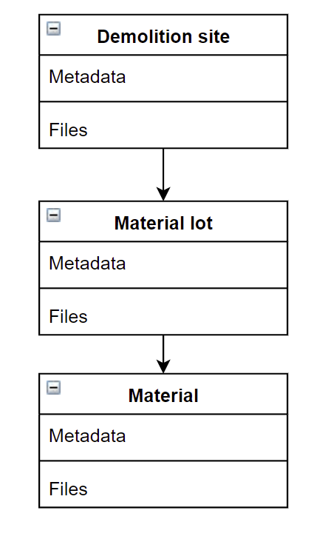
Figure 1. Database hierarchy diagram.

Using the databank
The operational idea is to store the data, and to deliver selected material stocks to the digital marketplace. Another CityLoops tool – 3D modelling tool for tracking the flows of on-site CDW – provides 3D models and digital imagery from each of the monitoring session done onsite during the demolition process. This collected data is stored to the databank. 3D modelling tool provides calculated amounts of material lots, which are stored into the databank. Also possible other information such as documents concerning the demolition target can be stored into the databank. Material lots that are approved to be valid are delivered to the digital market place via digital connection or manually.

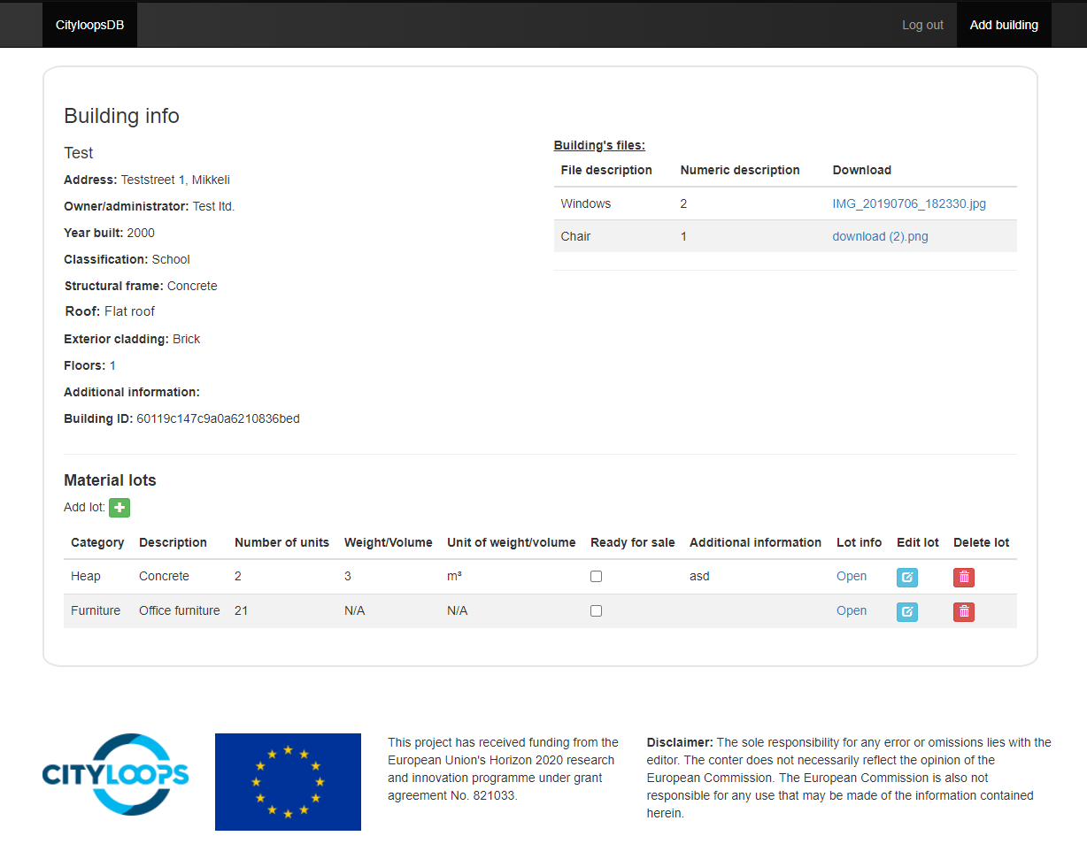
Figure 2. Mockup UI of the databank.

To start using the databank, a user must have their account be created through Keycloak by an administrator. The administrator may also assign them a role and a group (their organization) which will determine their level of access. Demolition sites (referred to as buildings in the mockup), and the files and data contained in them will be accessible to everyone in the creator’s group and to user accounts with the roles of admin or editor.
Users of the databank will be able to create sites. To create a site, the user must enter some basic information to identify the site such as a name, location, etc. Any files such as 3D models or reports can be stored under the site. Files can have a general description and a separate numeric description. The numeric description can be used, for example, to indicate the results of a contaminant mapping report at a glance.
Once the site has been created, material lots can be added to the site. Material lots are categorized into heaps or loose furniture. A lot can be divided into individual materials, such as a specific heap or a single piece of furniture. Materials can also have files and metadata attached to them, but they can only be entered into the online marketplace as a lot. Entering a lot into the digital marketplace is done by checking the “Ready for sale” checkbox in the material lots list (not yet implemented as of March 2021).

Summary
Once deployed, the databank alpha version is ready to accept users and can be used to store information and files on demolition sites. The databank will undergo further development in the CityLoops demonstration phase. Data fields relating to sites, material lots, and materials will be tweaked according to emerging user needs, and the integration with the digital marketplace operated by Miksei will be implemented after the database is deployed and operational.

